**MACHAKOS UNIVERSITY**

**SCHOOL OF ENGINEERING AND TECHNOLOGY**

**DEPARTMENT OF COMPUTING AND INFORMATION TECHNOLOGY**

**VIRTUAL DOCTOR**

**DENNIS MWANGI CHIIRA**

**J77-1285-2018**

**PROJECT PROPOSAL SUBMITTED IN PARTIAL FULFILLMENT OF THE REQUIREMENTS FOR THE AWARD OF THE DEGREE OF BACHELOR OF SCIENCE, INFORMATION TECHNOLOGY**

**2022**

# **DECLARATION**

I hereby declare that this project documentation is based on my original work except for citations and quotations which have been duly acknowledged. I also declare that it has not been previously and concurrently submitted for any other degree or award at any University.

**Student:**

Dennis Chiira

Sign……………………………………….. Date…………………………

**Supervisor:**

Mr. Omuya Erick

Sign……………………………………….... Date…………………………

# **ACKNOWLEDGMENT**

I thank God because of His guidance and strength, without which this would not have been possible.

I express my sincere gratitude to my supervisor for their advice, and encouragement that enabled the success of this project.

I am grateful to my brother who has guided me through my programming process, his support since I wrote my first line of code to date.

# **ABSTRACT**

The growth of the internet and increase use of smartphones, digital devices and technologies and mobile devices has enabled a new generation of information consumers to satisfy their demands for access to services without the need to meet in a physical location. Health institutions have embraced use of information systems to satisfy the various aspects and functions. Record keeping and retrieval of patient profiles and documents has been made easy. Currently, the information systems are majorly used for record keeping, patient data retrieval, doctor-patient scheduling, and drug prescription. These information systems do not offer a comprehensive solution on how users can handle emergency situations.

The main aim of carrying out this project proposal is to develop an online platform that would allow access of emergent and non-emergent health assistance and facilities. The first chapter of the project proposal will discuss information systems and how they affect health service provision. In the second chapter, the proposal will take a look at the literature review to understand how information systems have been used to provide online health services in other platforms. This will be important in showing the relationship in these information systems and the proposed system, to come up with a solution to the still available problems on online health service provision. The research design of the system will be done in chapter three, and used tho support and improve on online health service provision. The outcome of the research will provide a blueprint in the development of the proposed system.

# **DEDICATION**

I dedicate this project to myself for working hard and not giving up, my family and my friends for their support and encouragement during this entire time. My Supervisor has supported and guided me on, and I sincerely appreciate all the effort. God bless them all.

Table of Contents

DECLARATION i

ACKNOWLEDGMENT ii

ABSTRACT iii

DEDICATION iv

CHAPTER ONE 1

INTRODUCTION 1

1.1 Background Study 1

1.2 Problem Statement 2

1.3 Research Objectives 2

1.3.1 General Objective 2

1.3.2 Specific objective 3

1.5 Scope of the Study 3

1.6 Justification of the Study 3

CHAPTER TWO 4

LITERATURE REVIEW 4

2.1 Introduction 4

2.2 Historic Review 4

2.3 Related Systems 5

2.3.1 Machakos Level Five Hospital Information System 5

2.3.2 The Aga Khan Hospitals 5

2.3.3 MP Shah Hospital, Nairobi 5

2.4 Summary of Gaps 6

CHAPTER THREE 7

RESEARCH METHODOLOGY 7

3.1 Introduction 7

3.2 Research Design 7

3.2 Population and sampling 7

3.3 Methods of Collecting Data 7

3.3.1 Questionnaire 8

3.3.2 Interviews 8

3.4 Data analysis 9

3.5 System Development Methodology (Waterfall methodology) 9

3.5.1 Requirement Analysis 10

3.5.2 Design Phase 10

3.5.3 System Implementation 11

3.5.4 Testing 11

3.5.5 Review and Maintenance 11

CHAPTER FOUR 12

SYSTEM ANALYSIS AND DESIGN 12

4.1 Data Analysis Results 12

Table 2:Data Analysis Result 12

4.2 Requirement Analysis 13

4.2.1 Functional Requirements 13

4.2.2 Nonfunctional Requirements 14

4.3 Propose System Architecture 14

Figure 5 System Sequence Diagram 17

Fig 7 Admin and ser Roles Data Flow Diagram 19

CHAPTER FIVE 23

IMPLEMENTATION AND TESTING 23

5.0 Introduction 23

5.1 Development Tools 23

5.2 Testing 24

5.3 Proposed Changeover Strategy 25

CHAPTER SIX 38

CONCLUSIONS AND RECOMMENDATIONS 38

6.0 Introduction 38

6.1 Discussion 38

6.2 Recommendation 38

6.3 Future Work 38

6.4 Conclusion 38

REFERENCES 40

Budget 41

Project Activities 42

Project Schedule 42

# **CHAPTER ONE**

# **INTRODUCTION**

The proposed project is to develop a web-based application with a progressive web application for qualified medics, patients, and the general public. The web-based project will help patient access health services online, locations, information about specific services provided. The platform

will help with handling emergent and non-emergent health issues, therefor reducing congestion in these facilities. Users of the platform will be able to see the location of near health facilities and the services offered, preventing confusion in case the user is in an unfamiliar location. The proposed system will help guide patients to the nearest facility with the needed service that can be regarded as an emergency.

In this chapter, we will have an overview of the current systems used in online health service provision, then compare that with the system intended to improve on the platforms. Our topics will be looking at the background study of the systems in place and the problems associated with them. We will also look at the benefits of solving the current impairments. The benefits of the proposed Information Management System will be that it will provide a fast and accurate access to information that patients and users may need to respond to emergencies. The system will have a central data repository where the entire data will be stored. In summary the proposed project will give medic, patient, and the general public an easy solution to emergent and non-emergent health services and facilities.

## **1.1 Background Study**

There is a great increase in use of smartphones and the internet. Industries have also incorporates use of the internet to provide services, marketing, reaching and interacting with it’s customers. Public and private organizations have implemented web applications to provide their services over the web. A web application is a program that is store on a remote server and delivered over the internet via a web browser interface. Currently all smartphones come with a pre-installed web browsers. There is also an increase in the use of progressive web applications.

A progressive web application (PWA) is a website that looks and behaves as if it is a mobile app. PWAs are built to take advantage of native mobile device features, without requiring the end user to visit an app store, make a purchase and download software locally.

Google maps allow for Geo-location tracking, an online service that helps tracking devices, which will be important in development of the platform to allow tracking of the user in case of emergencies

## **1.2 Problem Statement**

The current systems are majorly used in consultation, doctor-patient scheduling, teleconferencing and real time communication via text or video calls, health classes and drug prescriptions.

Accidents, health complications happen everyday and everywhere. People currently want everything to be instantaneous and accessible. If a medical emergency occurs and the user is unfamiliar with the region they are currently in or needs to locate the nearest health facility, it will take time to search and find a health facility addressing the emergency at hand which may lead to life loss in critical situations. Sometimes accidents happen and the surrounding people have no medical experience resulting to tension and can only watch as life is being lost with the best thing to do calling for an ambulance.

When looking online a number of hospitals do not have basic websites leave alone providing services online therefore a need for a single platform with a list of hospitals linking to their services without ambiguity. The problem is that humans are prone to medical risks that may be an emergency or non-emergent. If the issue is non-emergent the user may not necessarily need to physically visit a hospital. In case the issue a hand is emergent and the user incapable of walking or driving themselves to a medical facility, they may as well request for help.

Let’s take in instance where one is on a trip in an unfamiliar region with a friend or partner who has no medical experience and a medical emergency arises. The normal response would be tension and confusion for the partner. The partner may not know emergency numbers to call in that area and describe exactly where their current location is. What steps of action should the friend or partner take?

## **1.3 Research Objectives**

### **1.3.1 General Objective**

To design and implement a web platform and a progressive web application that allow users access medical facilities around them with ease when facing emergent or non-emergent health issues.

### **1.3.2 Specific objective**

1. To gather and analyze information on the present systems used to provide health services.
2. To provide a report outlining the design of an online health service provision platform.
3. To design a web-based online health service provision platform.
4. To develop a web-application and progressive web application that does fairly well with low internet bandwidth.
   1. **Limitations of the study**

The most significant obstacles to overcome are:

1. Easy creation and access of user accounts by patients using the system.
2. Easy to use for people of all ages.
3. Informing people about existence of the platform and how to use it.
4. Internet access for everyone.

## **Scope of the Study**

The information system will lie within the limits of providing patients and medical practitioners with an online platform from where the patient can access emergent and non-emergent health assistance from qualified medical practitioners, and health facilities.

## **Justification of the Study**

After the web-application is complete, patients will not have to visit the health facilities physically when consulting with the medical practitioners. People will have access to the locations of the near health facilities when unfamiliar with their terrain, and in case of an emergency users of the platform can perform simple but critical first aids on those requiring the assistance, access to ambulances near you will be easier, and finally, users will be directed directly to the nearest health facilities with the required services, a great example is for those who need anti-venom can directly go to the health facility with the anti-venom without any wasting of sensitive time.

# **CHAPTER TWO**

# **LITERATURE REVIEW**

## **2.1 Introduction**

The main purpose of studying the existing system is identifying an existing gap and develop a system which adds to the effective functionality of the current system. Machakos Hospital information management system is useful in record keeping, retrieval of patient information, view the history of the patient, and help in diagnosing and giving prescriptions to the patient. But, the existing system has several weaknesses which we will look at in this chapter and also related systems previously used for health service provision.

## **2.2 Historic Review**

During the past 150 years, two factors have shaped the modern public health system: first, the growth of scientific knowledge about sources and means of controlling disease; second, the growth of public acceptance of disease control as both a possibility and a public responsibility. In earlier centuries, when little was known about the causes of disease, society tended to regard illness with a degree of resignation, and few public actions were taken. As understanding of sources of contagion and means of controlling disease became more refined, more effective interventions against health threats were developed. Public organizations and agencies were formed to employ newly discovered interventions against health threats. As scientific knowledge grew, public authorities expanded to take on new tasks, including sanitation, immunization, regulation, health education, and personal health care. (Chave, 1984; Fee, 1987)

The link between science, the development of interventions, and organization of public authorities to employ interventions was increased public understanding of and social commitment to enhancing health. The growth of a public system for protecting health depended both on scientific discovery and social action. Understanding of disease made public measures to alleviate pain and suffering possible, and social values about the worthiness of this goal made public measures feasible. The history of the public health system is a history of bringing knowledge and values together in the public arena to shape an approach to health problems. (<https://www.ncbi.nlm.nih.gov/books/NBK218224/> )

## **2.3 Related Systems**

Below are the related systems that have been researched in the proposed system.

### **2.3.1 Machakos Level Five Hospital Information System**

Currently in Machakos level five hospital, despite their lack of a website, there is an information system but does not allow for online health service provision i.e when one is faced with a medical issue, one has to physically go to the hospital and access their services, whether seeking for treatment or consulting. The current system in place lacks a platform from where patients an interact with medics for consultation, drug prescriptions, and a complete list of the services being provided. Online health service provision should be necessitated to users to allow for more flexibility and more accessibility of their services.

### **2.3.2 The Aga Khan Hospitals**

Aga Khan hospitals have an online platform that allow users to see the services they provide, schedule for an appointment, and locate for an outreach center. They also provide a tele-consultation and triage that allows continuity of care and trialing of current and new patients. This service ensures you continue receiving the quality care you need from your doctor, via phone or zoom. Despite this, they do on offer a platform from where they can help users handle emergency health issues or accidents.

### **2.3.3** [**MP Shah Hospital, Nairobi**](https://mpshahhosp.org/)

MP Shah hospital offers an online platform that allows users to make virtual consultations, emergency contact number, but lacks a way to track user devices in case of emergency services have been requested by a user i.e an ambulance.

The proposed system will allow for health facilities to track patient exact locations using Google maps for easy tracking and access to the patient in need of emergency aid.

## **2.4 Summary of Gaps**

The introduction of information system will provide an interconnection of information system where resources can be easily shared with the electronic system as compared to the traditional way of health service provision. As we have seen from the literature review with the development of an improved health service provision platform, non-emergent issues can be handled there reducing congestion in health facilities and help track users in case of any emergencies, aid in tracking of patients requesting for ambulance services

**2.5 Conceptual framework**

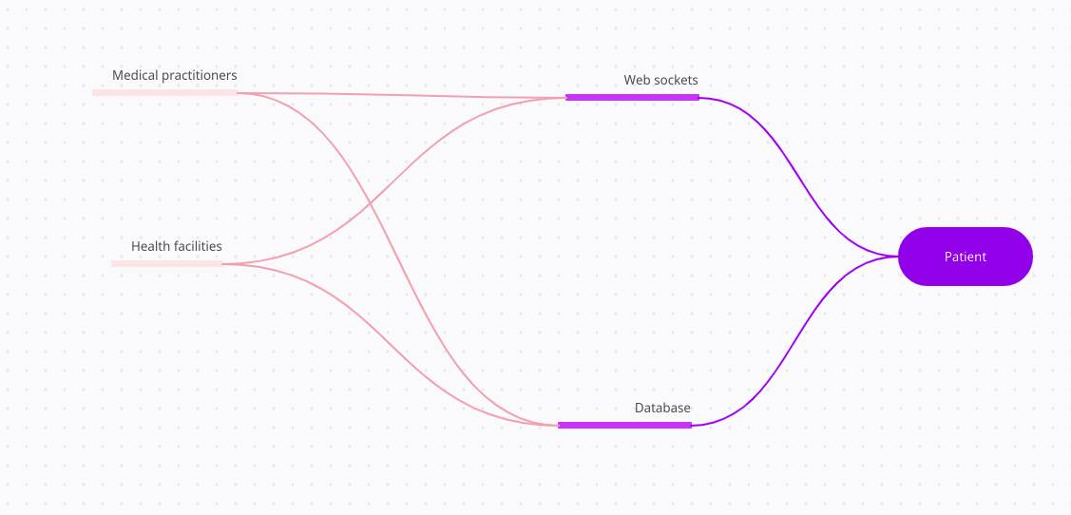**Figure 1 framework**

The conceptual framework shows the interaction between the patient and the medic or the health facility. The patient sends a request to the health facility via database for consultation and the process is actualized via a web socket allowing for the interaction with the medic for emergent or non-emergent issues.

# **CHAPTER THREE**

# **RESEARCH METHODOLOGY**

## **3.1 Introduction**

This chapter will highlight the research design of the project, the population being sampled, methods of collection of data and Data analysis of the proposed project. The purpose of this chapter is to provide a detailed plan that helps to keep researchers on track, making the process smooth, effective and manageable.

The research process used in the proposed project was qualitative research as it focused on people's perception, experiences, ideas or feelings. (merriam et al, 2003) Understanding this experience is more important than looking for an outcome.

## **3.2 Research Design**

The entire approach taken to do research, known as research design, establishes a logical plan to address predetermined research questions through the gathering, interpreting, analyzing, and presenting of data. The appropriate type of design is determined by the research challenge. The proposed system's research will be conducted using an exploratory research design in order to comprehend the problem more fully. Due to a lack of prior research, the exploratory research design is adopted. Data collection will start with interviews to random residents of Machakos, Machakos level five hospital medics, on how services are offered and how emergency and non-emergent health issues are handled.

## **3.2 Population and sampling**

Students and project supervisors will be selected on the basis of their knowledge and experience, the sampling method used is judgmental sampling. The researcher uses his or her judgment in selecting the unit of population for the study. The students and project supervisors will be contacted through their emails in regards to interviewing them on the topic at hand. Judgmental sampling design is usually used when a limited number of individuals possess the trait of interest. It is the most appropriate sampling technique for this study since the information required could best be obtained from a specific group of staff and students in the company.

## **3.3 Methods of Collecting Data**

Data collection is the process of methodically gathering and evaluating information on pertinent factors in order to test hypotheses, gather answers to research questions, and evaluate outcomes. One technique was used in this investigation to collect data. Hybrid data, which combines primary and secondary data, will be the sort of data that will be gathered. Interviews and questionnaires will be used to gather primary data, and records from medical centers will be used to gather secondary data.

### **3.3.1 Questionnaire**

To cut down on costs, the data will be gathered using a questionnaire. Several of the major inquiries that will be posed include;

1.How are emergent health issues from patients handled ?

2.How is a patient requesting for an ambulance tracked ?

3.How are consultations with patients handled ?

With collection of multiple data from various medics and patients or the general public, a good approach will be taken to help build a reliable system that will be of great help after analysis.

**Merits of questionnaire**

1. It is relatively cheap.
2. It can be done virtually therefore it is fast.
3. It allows for anonymity of the users.

**Demerits of questionnaire**

1. Close ended questions may limit ones responses.
2. Inability to read and write may hinder the process.
3. Susceptible to false and inaccurate data.

### **3.3.2 Interviews**

Because the data sources for qualitative research can be so varied, a semi-structured interview method was selected. Interviews will be done to offer every member of the population under investigation an equal opportunity to voice their opinions. A series of questions will be posed to the interviewee during our one-on-one conversation in a relaxed setting. The difficulties students and project managers experience in trying to tackle the current issue encountered during the project development phase and how to improve the suggested system are some of the issues that will be asked.

**Merits of interviews**

1. Allows for a deeper connection with interviewees.
2. The interviewee has a space to provide more feedback.
3. The feedback provided is instant

**Demerits of interviews**

1. It is time consuming.
2. Interviewees may be unwilling to be interviewed.

## **3.4 Data analysis**

Data analysis is the process of condensing research data into digestible summaries. The inductive technique will be utilized to evaluate narrative data, and Nvivo will be the program used for the analysis.

The three procedures that will be utilized to assess the qualitative data collected include:

1. handling compressed data

It entails verbalizing observed behavior and converting interviews from audio to written form.

1. Data condensing

Editing the data and removing uncertainty accomplishes this. Editing is crucial for getting rid of mistakes like grammatical ones without affecting the original data. In order to eliminate ambiguity in data, repetitive phrases or words must be eliminated. The information will then be divided into groups based on how closely related the groups are to one another.

1. A presentation of the results.

In order to provide clarity during analysis and to help others understand what is being said, visualization is crucial. Charts will be utilized to depict the qualitative data and present the findings from data analysis and the resulting useful information that will be used to address the project's problem statement.

## **3.5 System Development Methodology (Waterfall methodology)**

In the proposed project the waterfall methodology will be used in development since the requirements are completed early in the project, enabling the team to define the entire project scope, create a complete schedule, and design the overall application.

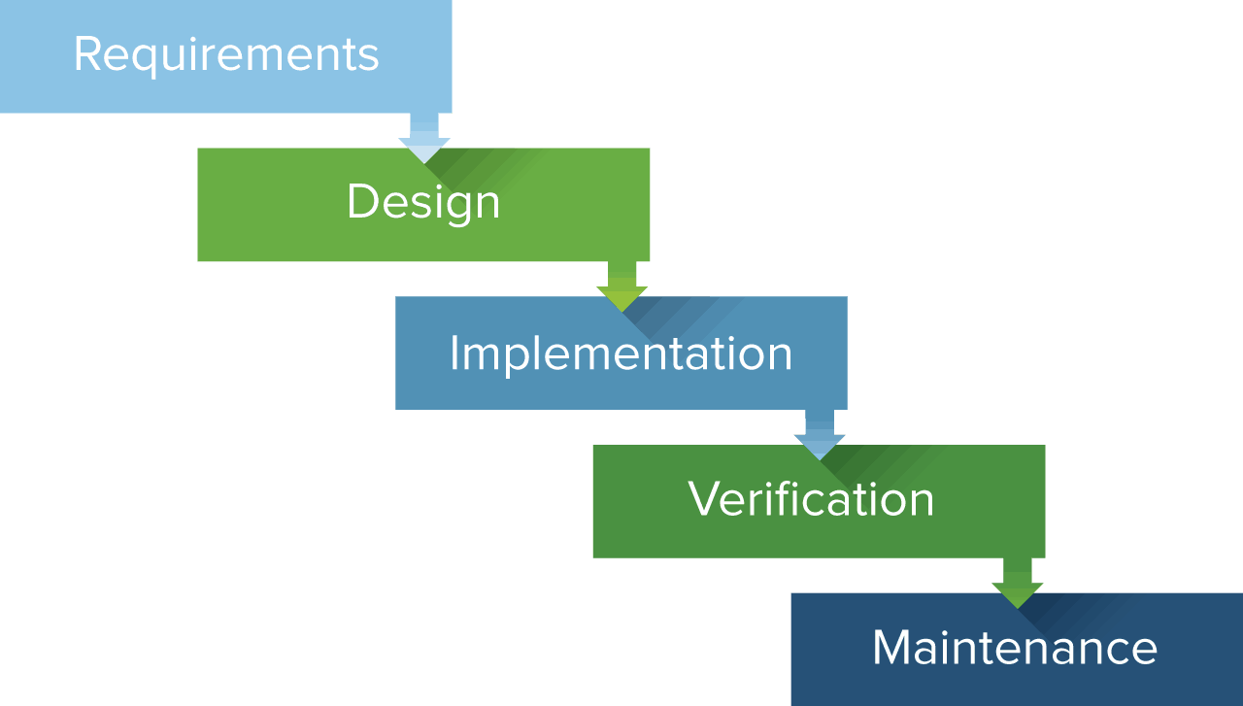

**Figure 2 Waterfall Methodology**

It is also referred to as a linear-sequential life cycle model. It is very simple to understand and use. In a waterfall model, each phase must be completed before the next phase can begin and there is no overlapping in the phases.

### **3.5.1 Requirement Analysis**

After the current systems have been investigated and the specifications documented, an analysis of the data will be done to give a clear understanding of the system.

### **3.5.2 Design Phase**

The specifications of the current system were examined to ascertain what modifications were required to accommodate the user needs that were not currently being addressed by the system. The result of this phase consists of the specifications, which outline the functions and features of the virtual doctor system.

### **3.5.3 System Implementation**

This phase includes installing the virtual doctor system in the actual working environment, training users, converting data as necessary, handing over the application to the sponsor, and assessing the operational procedures. This phase will cover the implementation-related tasks, system issues that were found during implementation, and sustainability planning.

### **3.5.4 Testing**

A series of unit, integration, performance, system, and acceptance tests will be used to validate the system. The goal will be to confirm that the apps perform as anticipated and that the project's criteria are met. We'll buy, test, and integrate every system component, communication, method, and related documentation. In order to verify complete testing of all requirements and to ensure that all requirements are met, this phase will involve significant user input.

### **3.5.5 Review and Maintenance**

This stage will see the system go into operation. During this phase, it will be crucial to make sure that the needs of the sponsor are met and that the system keeps performing as intended. The program will undergo routine hardware, software, and upgrade maintenance to maintain smooth operations. As necessary and necessary, user training will be conducted during this phase to familiarize new users with the system or to introduce new capabilities to current users. To assist in resolving any issues that have been reported, additional user support will be offered on a continuing basis.

**Adaptive maintenance -** The project tracker system will be modified after the project is finished in order to maintain its usability in dynamic contexts.

## 

# **CHAPTER FOUR**

## **SYSTEM ANALYSIS AND DESIGN**

## **4.1 Data Analysis Results**

Data that was collected through questionnaires, interviews, observation and in-depth literature review facilitated better understanding on the current issuing of lands and the issues that they face. The presentation of the data has been done according to users understanding of virtual doctor and their need of it.

Questionnaire

The questionnaires were researcher-administered. This method was used so as to gain more insights on the emergency handling. It also helped to ensure the respondents representative are that of the target audience. In addition it allows clarifications of ambiguous or unclear questions and answers. The goal of the questionnaire was to get feedback about how will the system change the lives of its users. Valid and reliable questions were included in the questionnaire. The data collected was then cleaned, analyzed and interpreted.

Open-ended questions were used. Example: How are emergencies handled in the country? How are emergencies handled? How will a land information system benefit you? How will a land emergency management system benefit the people?

Interview

The interviewee responded to well formulated questions on the problems of land management. Structured interview technique was used. At an appointed time, the researcher went for the interview with a summary of questions to be asked. Answers to the interview were recorded in the notebook and later transferred to the research report. Before such transfer, approval and permission was sought for the use of the collected data in the report.

Survey

A survey is a research where you collect and analyze data from a group of people. The target group was people between the age of 40 and above. The survey process included online filling forms.

## Table 2:Data Analysis Result

Views on how the system will impact the handling of emergencies and non-emergencies

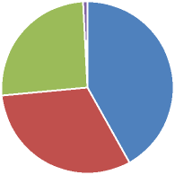



Figure 3: Analysis using a piechart

## **4.2 Requirement Analysis**

Through analysis of the data collected, the researchers were able to come up with a specification of complete functional and nonfunctional requirements, which outlines all facets of the system that was produced.

## **4.2.1 Functional Requirements**

i. Enhanced emergency handling Capability

There must be a proper searching procedure to help individuals find the required emergency handling. This will save people more time and the hustle of getting the perfect land to suit their needs.

ii. Enable Collaboration between medics and users.

The system must provide the users with registered facilities and their locations. This aspect should protect the users from fraud experts and agents.

iii. Provide an exact location of the Facility.

With the help of google maps the system must provide or pin point the exact location of the available health facilities.

## **4.2.2 Nonfunctional Requirements**

i. The system should be easy to maintain

ii. The system should be fast in performance and scalable

iii. The system should have an intuitive User Interface

iv. The system should be easily understood for both experienced and inexperienced users.

## **4.3 Propose System Architecture**

The three-tier architecture was adopted for this work. In this architecture, there are 3 main elements:

1. **The client tier**, that is responsible for the presentation of data, receiving user elements and controlling the user interface. Static or dynamically generated content rendered by the browser (front-end).
2. **The data server tier**, is responsible for data storage. A database, comprising both datasets and the database management system or RDBMS software that manages and provides access to the data (back-end). For this work, we used MySQL.
3. **The application server tier**, is responsible for the business logic of the system. In fact, business-objects that implements the business rules "live" here, and are available to the client-tier. Can also refer to a dynamic content processing and generation level e.g., Java EE, ASP.NET, PHP, ColdFusion platform (middleware). This tier protects the data from direct access by the clients. For this work, we used Laravel framework.

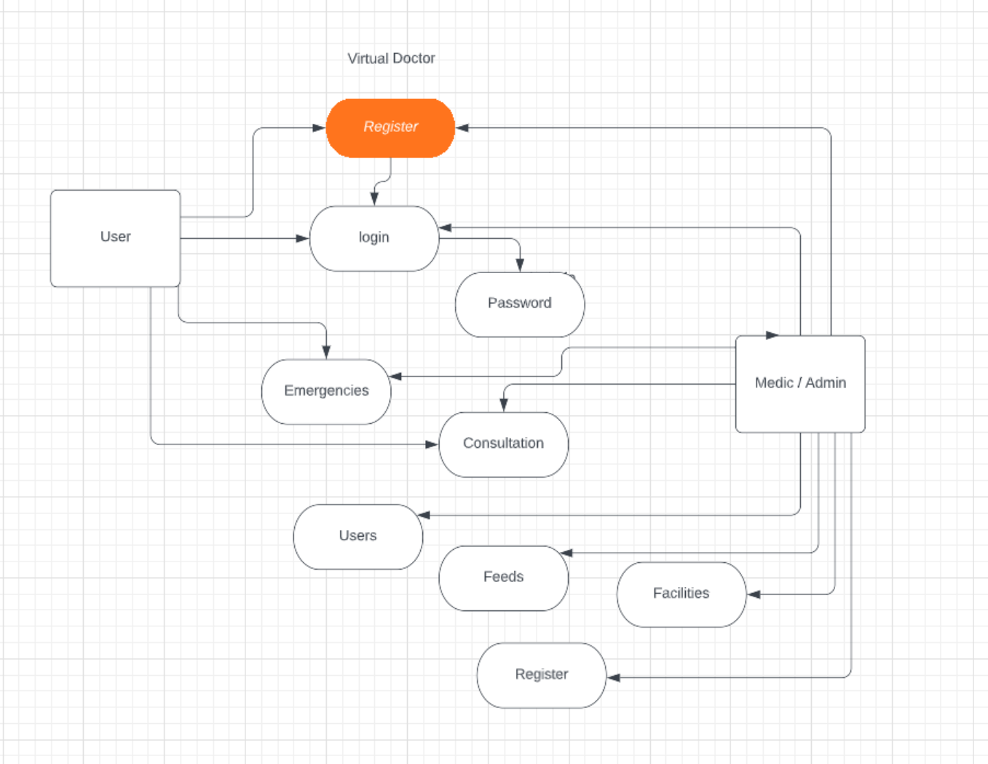

**Figure 3: Authentication Data flow diagram**

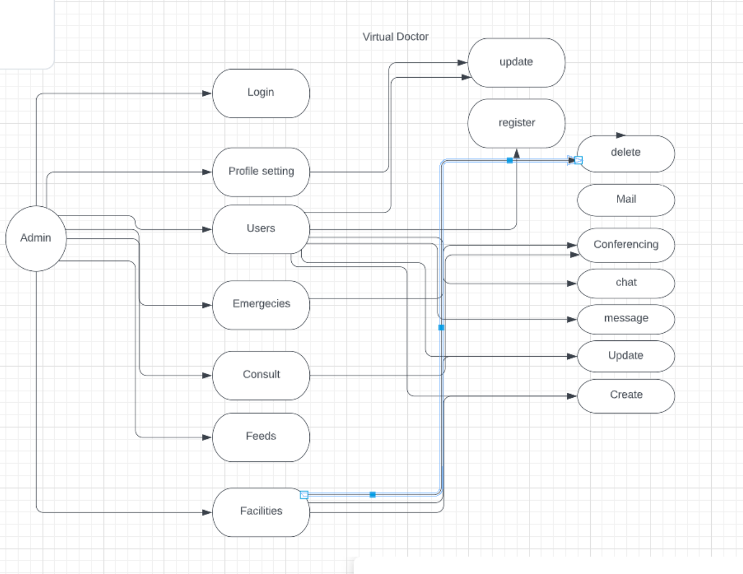

**Figure 4: Admin Roles Data flow diagram**

## **Figure 5 System Sequence Diagram**

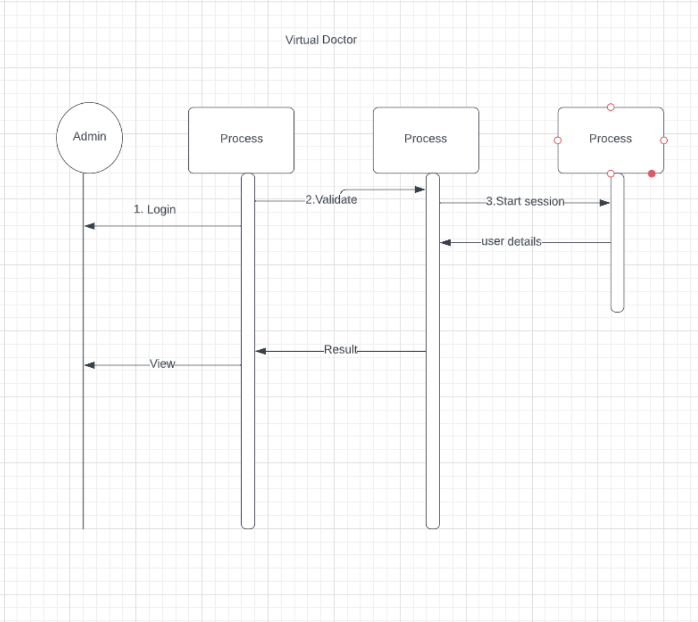

**Figure 6: Login System Sequence Diagram**

## **Fig** **7 Admin and ser Roles Data Flow Diagram**

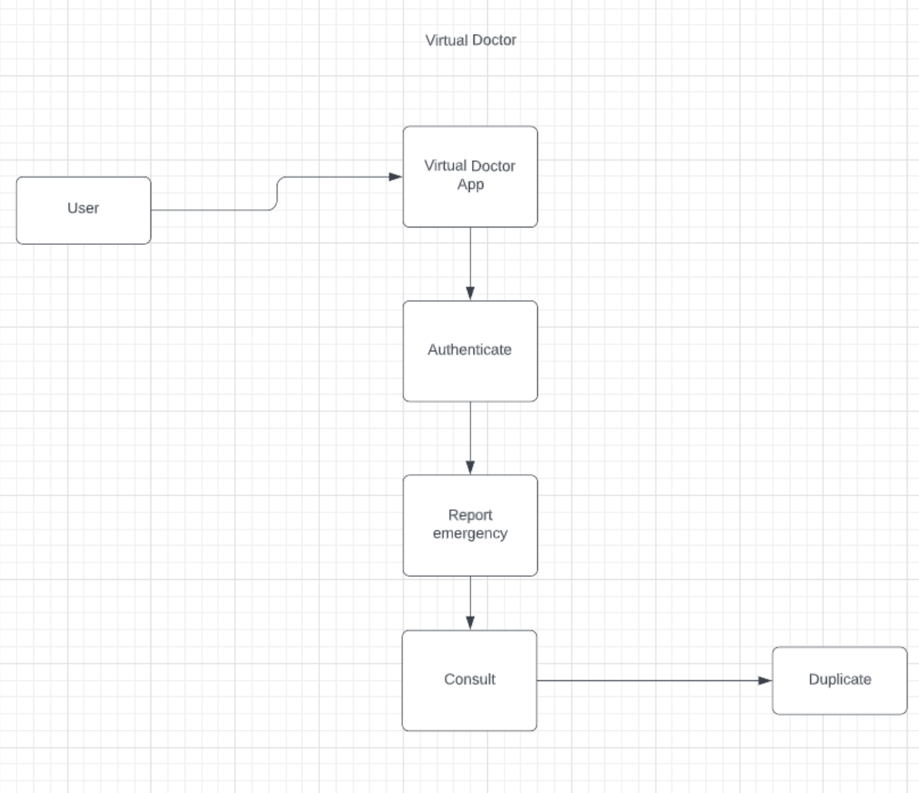**Figure 8: User Dataflow Diagram**

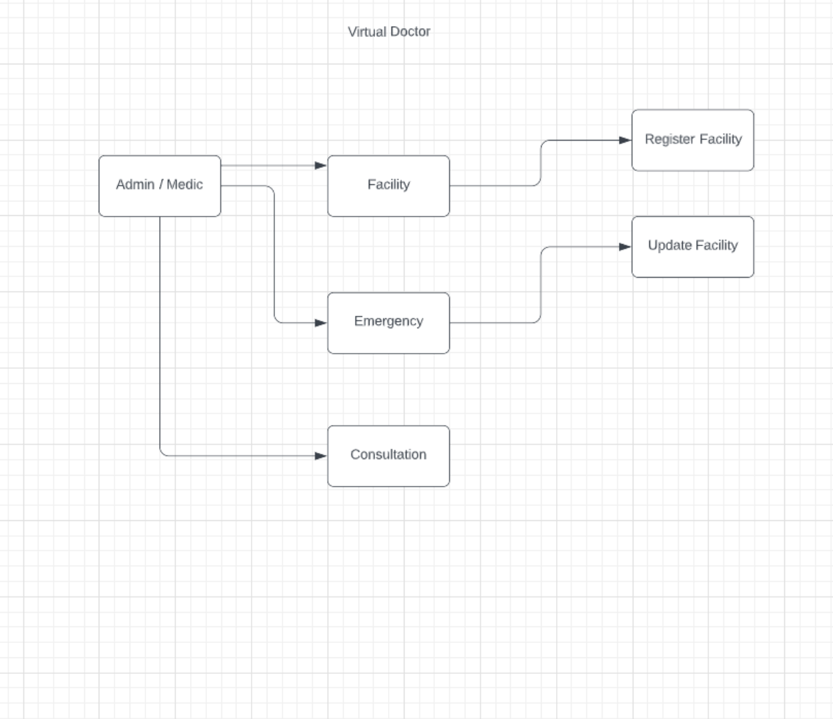**Figure 9: Admin Dataflow Diagram**

## 

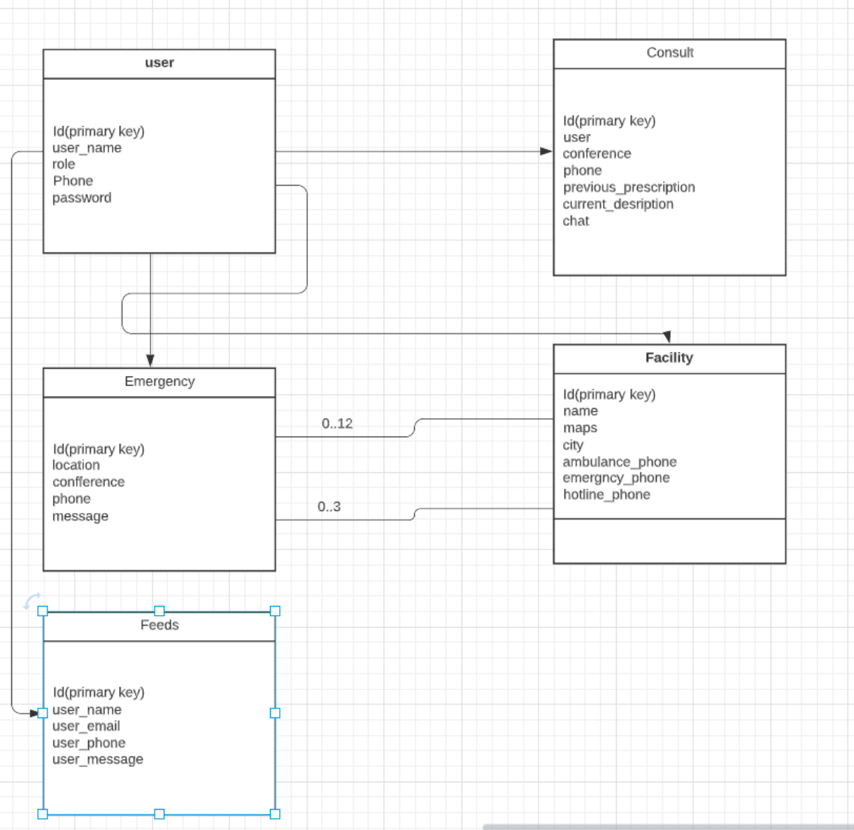**Figure 10: Relation Database**

# **CHAPTER FIVE**

## **IMPLEMENTATION AND TESTING**

## **5.0 Introduction**

The purpose of this chapter is testing of the system in order to define how functional it is and if it responds to the demands of the customer. Boris Beizer states “Testing only to end-user requirements is like inspecting a building based on the work done by the interior designer at the expense of the foundations, girders, and plumbing.” With this in mind, it is then important to test our project so as to find out what are the errors in our system. Software is tested to uncover errors that were made inadvertently as it was designed and constructed. (Pressman, 2010) According to Brad Egeland, “testing is an ongoing process, both formally and informally and happens in development, in the actual testing phase, just prior to deployment and post-deployment”. It is done so many times because it is important to ensure that the project submitted to the customer is error free and after deployment as well to make sure that the system or software was deployed without error and is functioning correctly.

## **5.1 Development Tools**

The tool used for this work are discussed below:

(i) Laravel

This is the server-side scripting language. It will serve as the back-end which will interact with the database, server and applets.

(ii) HTML

Hypertext Markup Language, commonly referred to as HTML, is the standard markup language used to create web pages. It will act as the front-end interface which will enable the user to interact with the system.

(iii) MySQL

This is a relational database management system (RDBMS). It will serve as the store house for all information concerning the system.

(iv) Adminer Database

Adminerl is the world's most widely used web server software. It was used as the platform to allow for interpretation of the server-side language and also facilitate serving of the system to the World Wide Web.

(v) Ubntu Operating System

Windows operating system is comprehensive, built-in and has ongoing security. It also has lower hardware requirements as well as an easy to use interface and desktop.

(vi) Visual Studio Code

Visual Studio Code is a code editor that provides a visual and a code editor with standard features such as syntax highlighting, code completion, and code collapsing as well as more sophisticated features such as real-time syntax checking and code introspection for generating code hints to assist the user in writing code, among many other features. It was used in the design & development phase as the system was being coded.

## **5.2 Testing**

A system test was created to assess the end-to-end system specifications. Typically, software is just one part of a bigger computer system. The program was eventually integrated with other software and hardware platforms. System testing is a collection of tests whose main objective is to put a computer-based system through its paces. The field of software testing known as black box testing includes system testing.

The testing of a software application's internal workings or code is known as white box testing. Black box or System Testing, on the other hand, is the polar opposite. System testing examines the software's exterior workings from the user's perspective.

Testing fully integrated programs, including external peripherals, to see how components interact with one another and with the entire system. This scenario is also known as End to End testing. Check for intended results by thoroughly checking each input in the program. The application's user experience is being tested.

That is a pretty simple summary of what system testing entails. Without looking at the source code, you must create extensive test cases and test suites that test each component of the program as perceived from the outside.

Unit testing

Unit testing is a testing approach in which the developer tests individual modules to see if there are any flaws. It is concerned with the independent modules' functional soundness. All of the system's components, including version control, security and collaboration activities, were independently evaluated and found to be functional.

Performance testing

The process of assessing the speed, responsiveness, and stability of a computer, network, and software under a workload is known as load testing. The technology worked with every common browser on the market (Mozilla Firefox, Opera mini, Google chrome). Although the accessibility speed did not match in all browsers, the system's operation was not compromised.

## **5.3 Proposed Changeover Strategy**

The manner through which a new system was implemented is referred to as the changeover strategy. The system was constructed utilizing a parallel changeover technique in this example. It was introduced to users while they continued to use the prior system. It worked side by side with the previous systems, providing the users with the services they required.

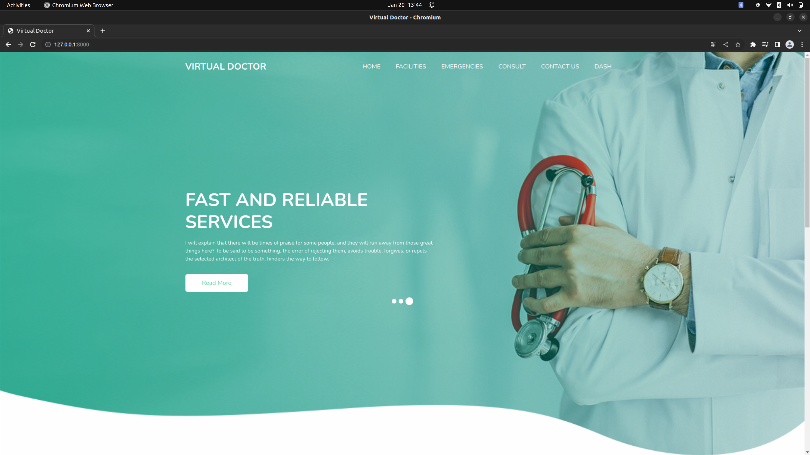**Figure 11: Home Page Interface**

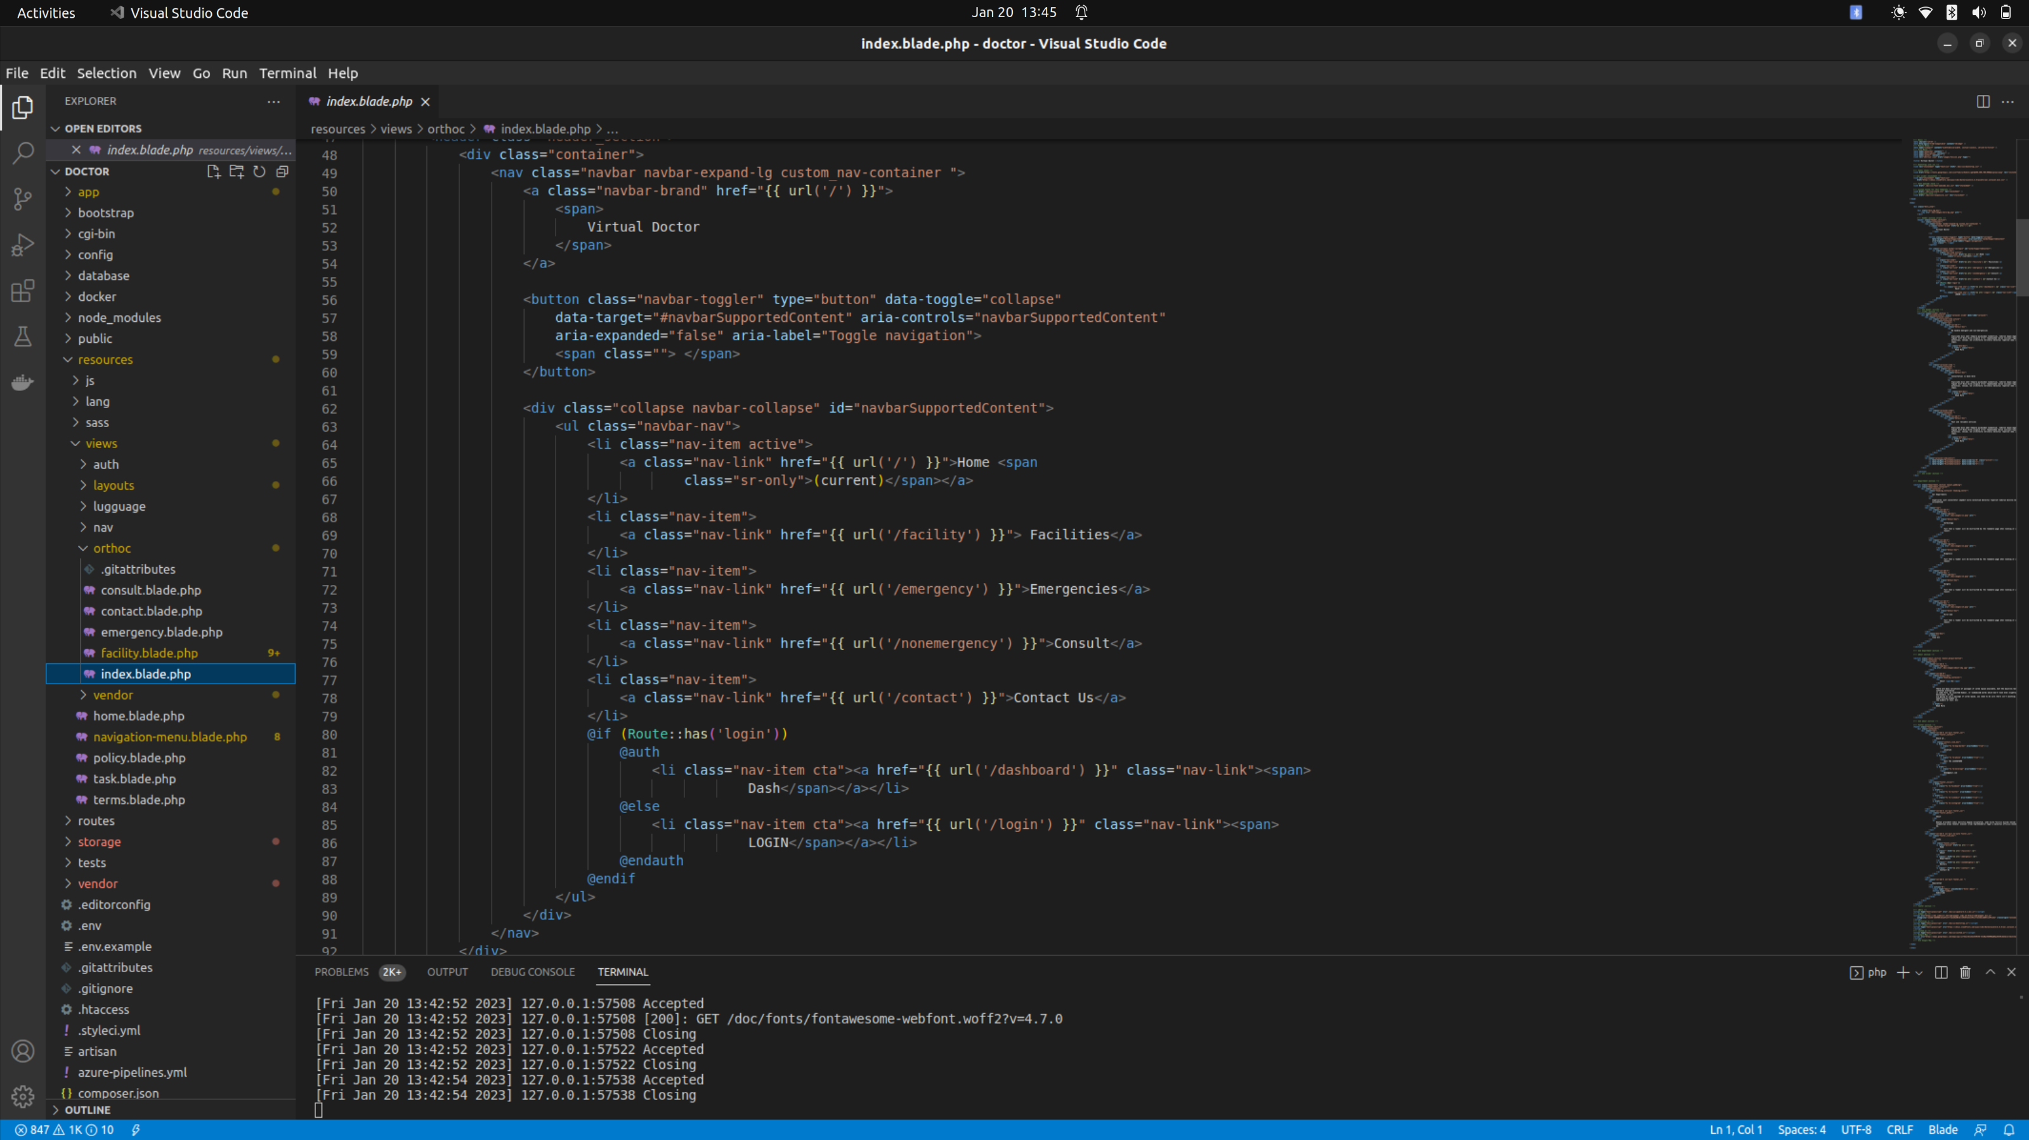**Figure 12: Home Page Code**

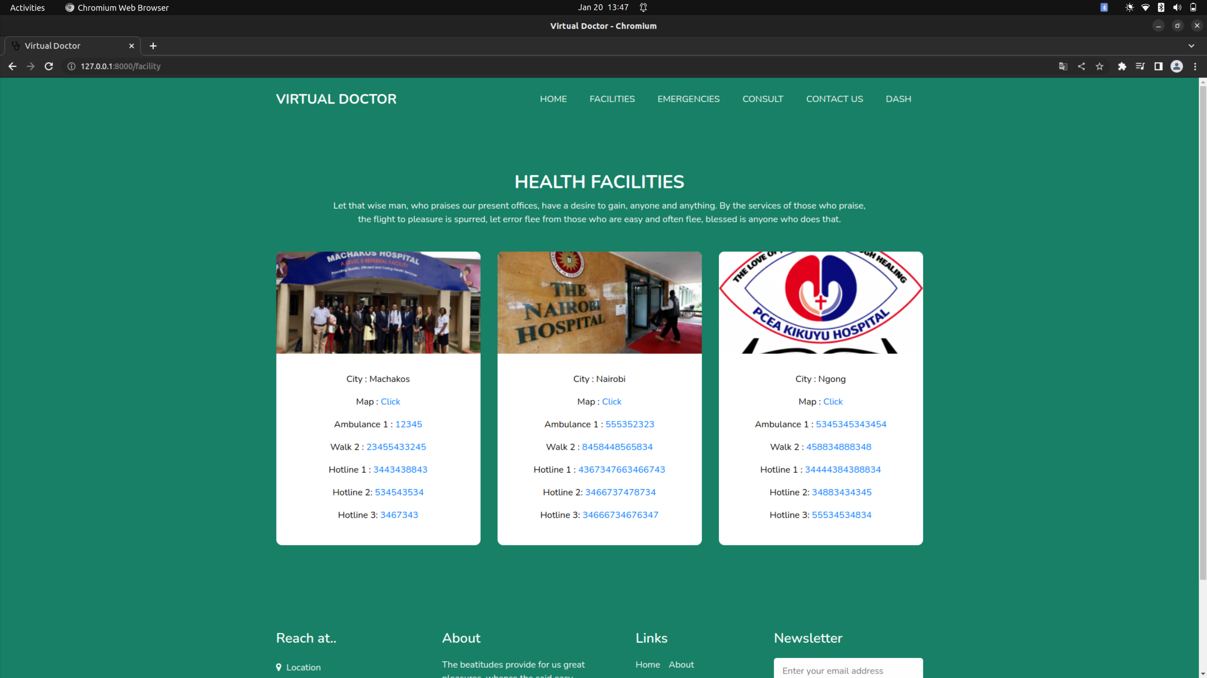**Figure 13: Facility Interface**

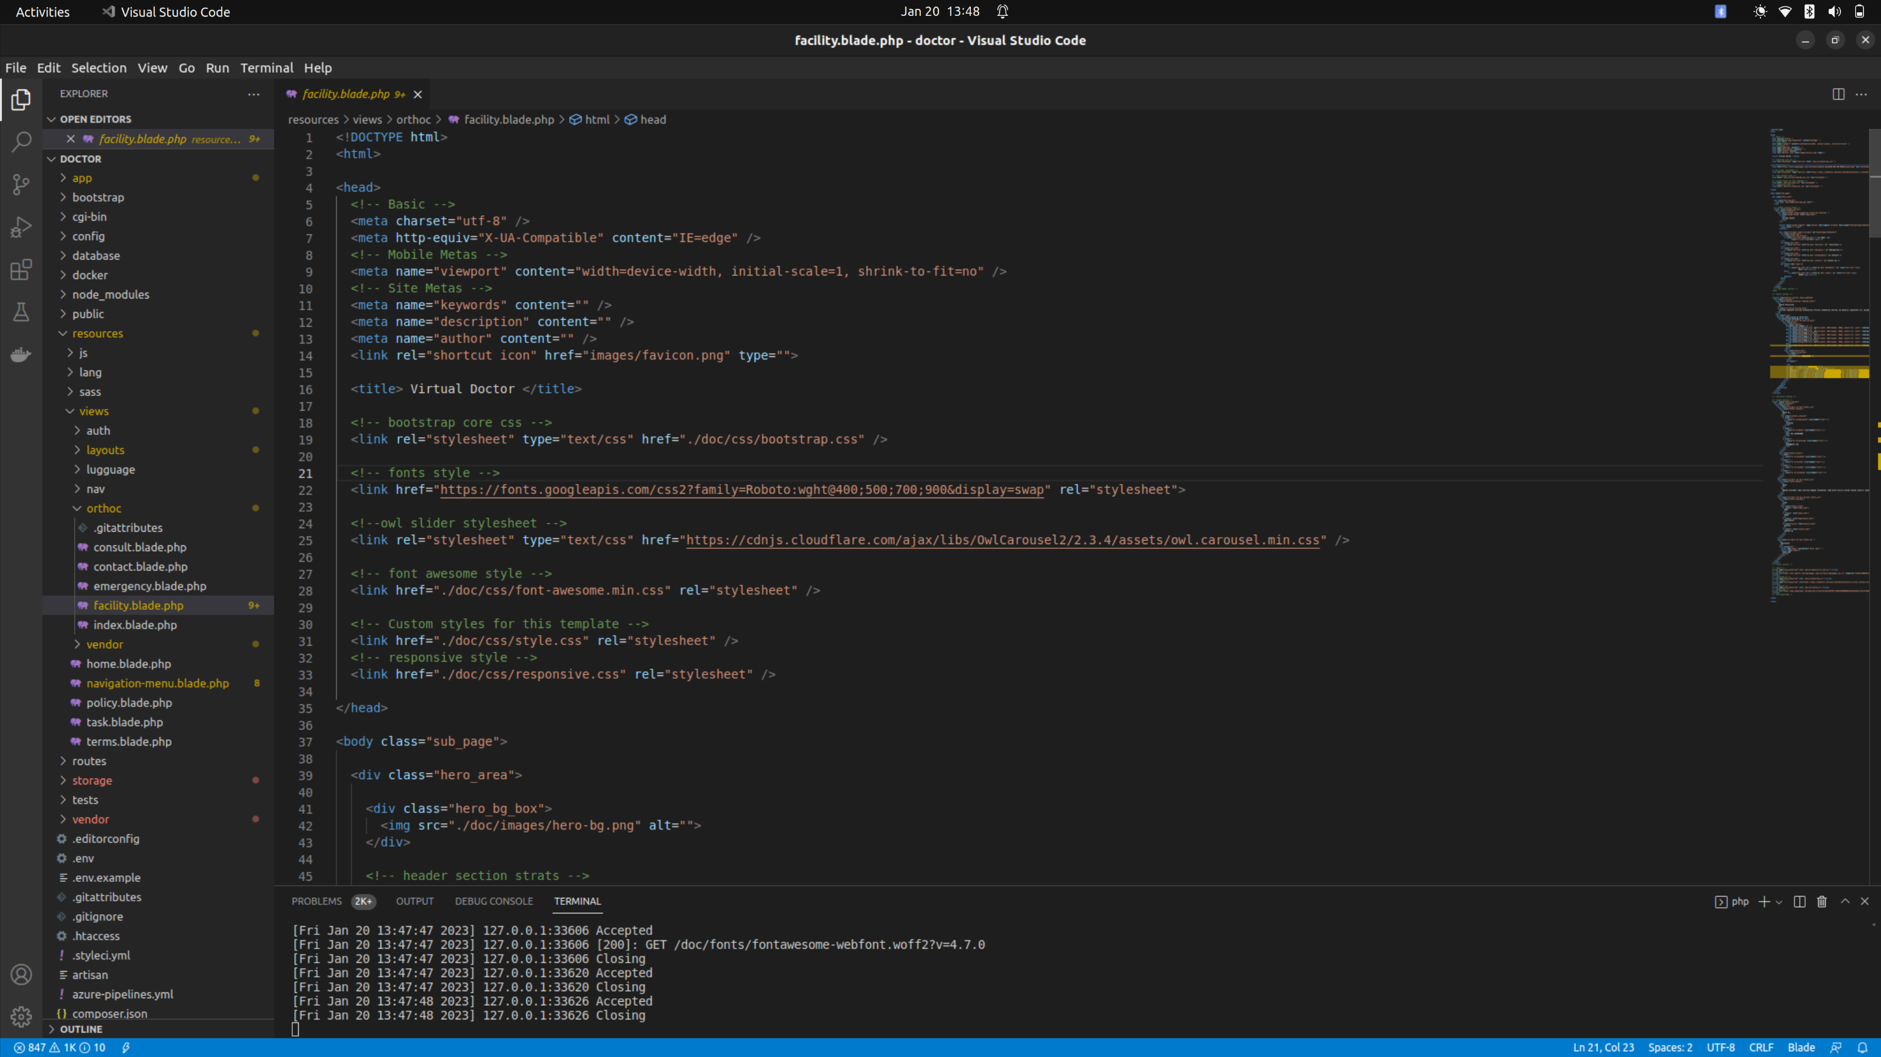**Figure 14: Facility Code**

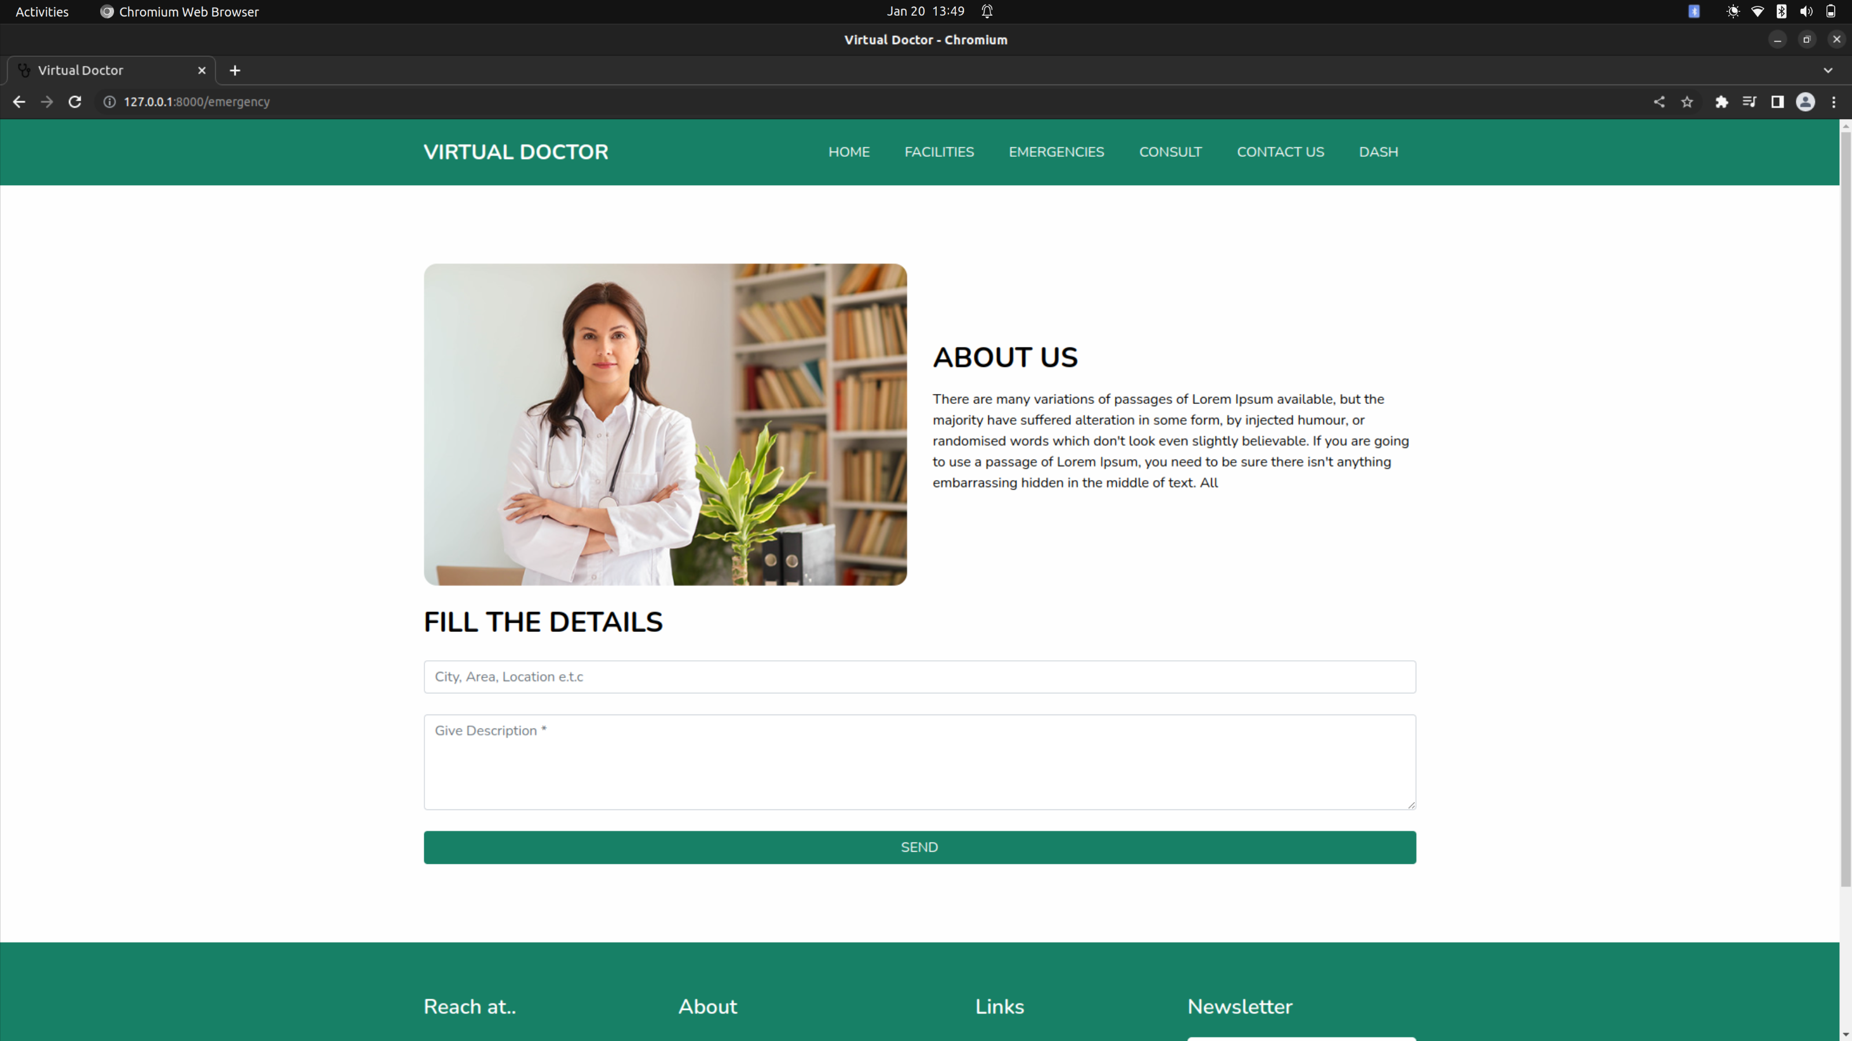**Figure 15: Emergence Interface**

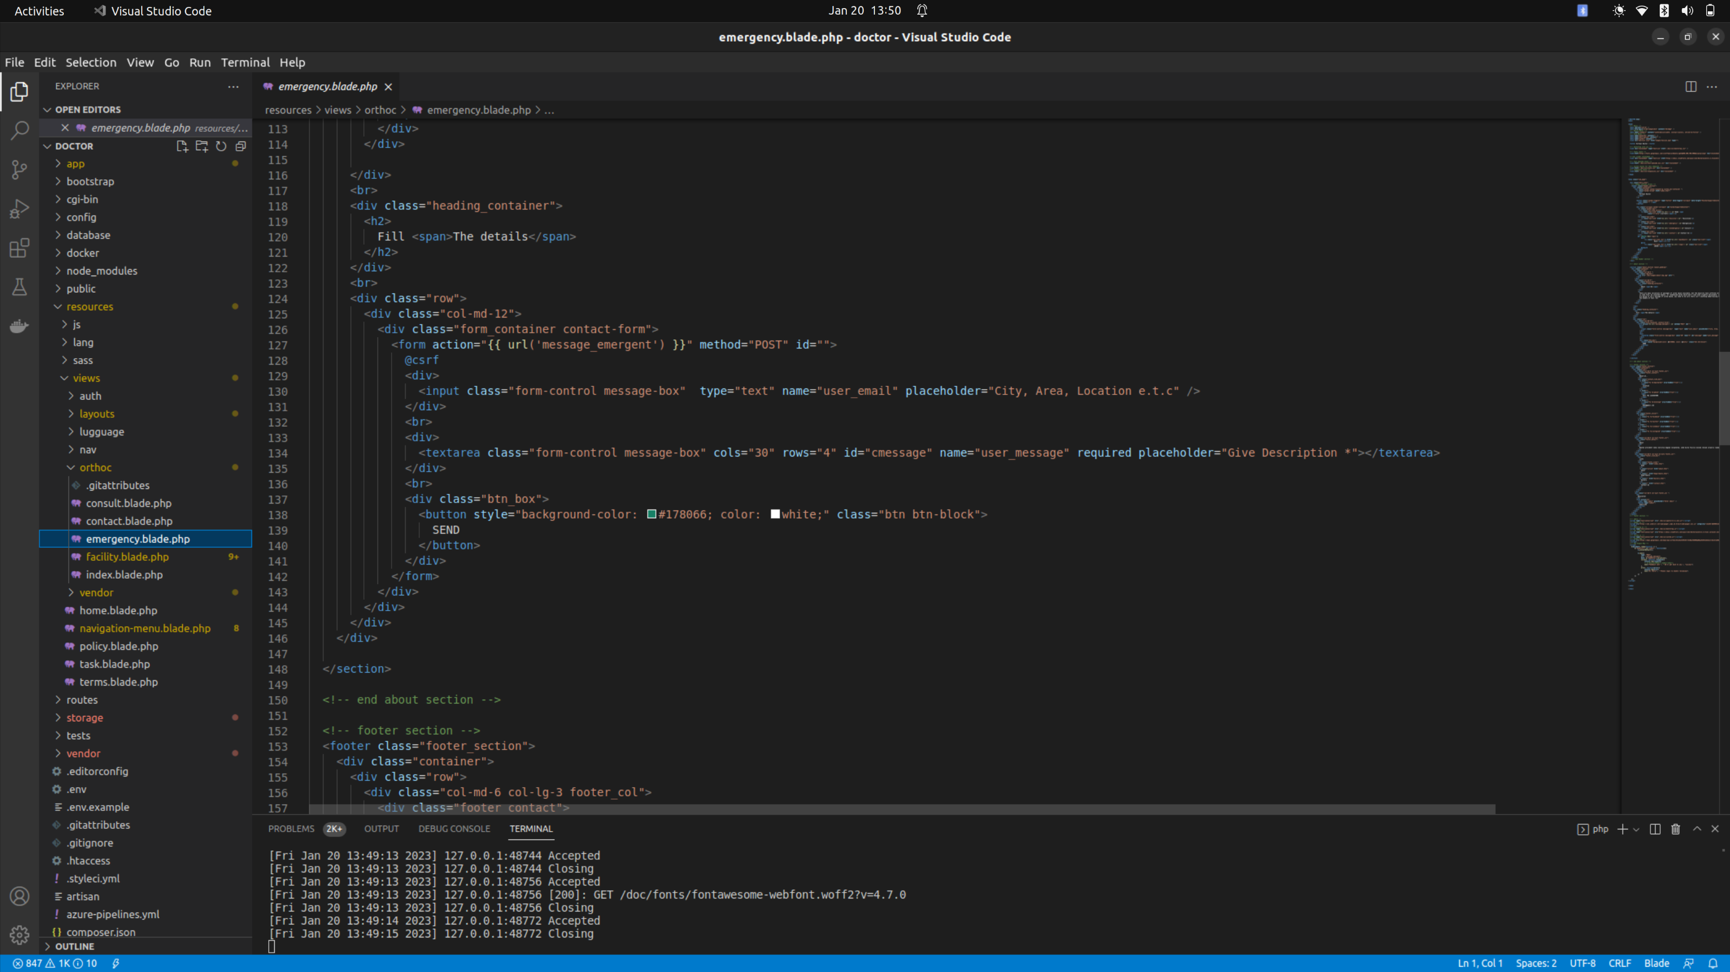**Figure 16: Emergence Code**

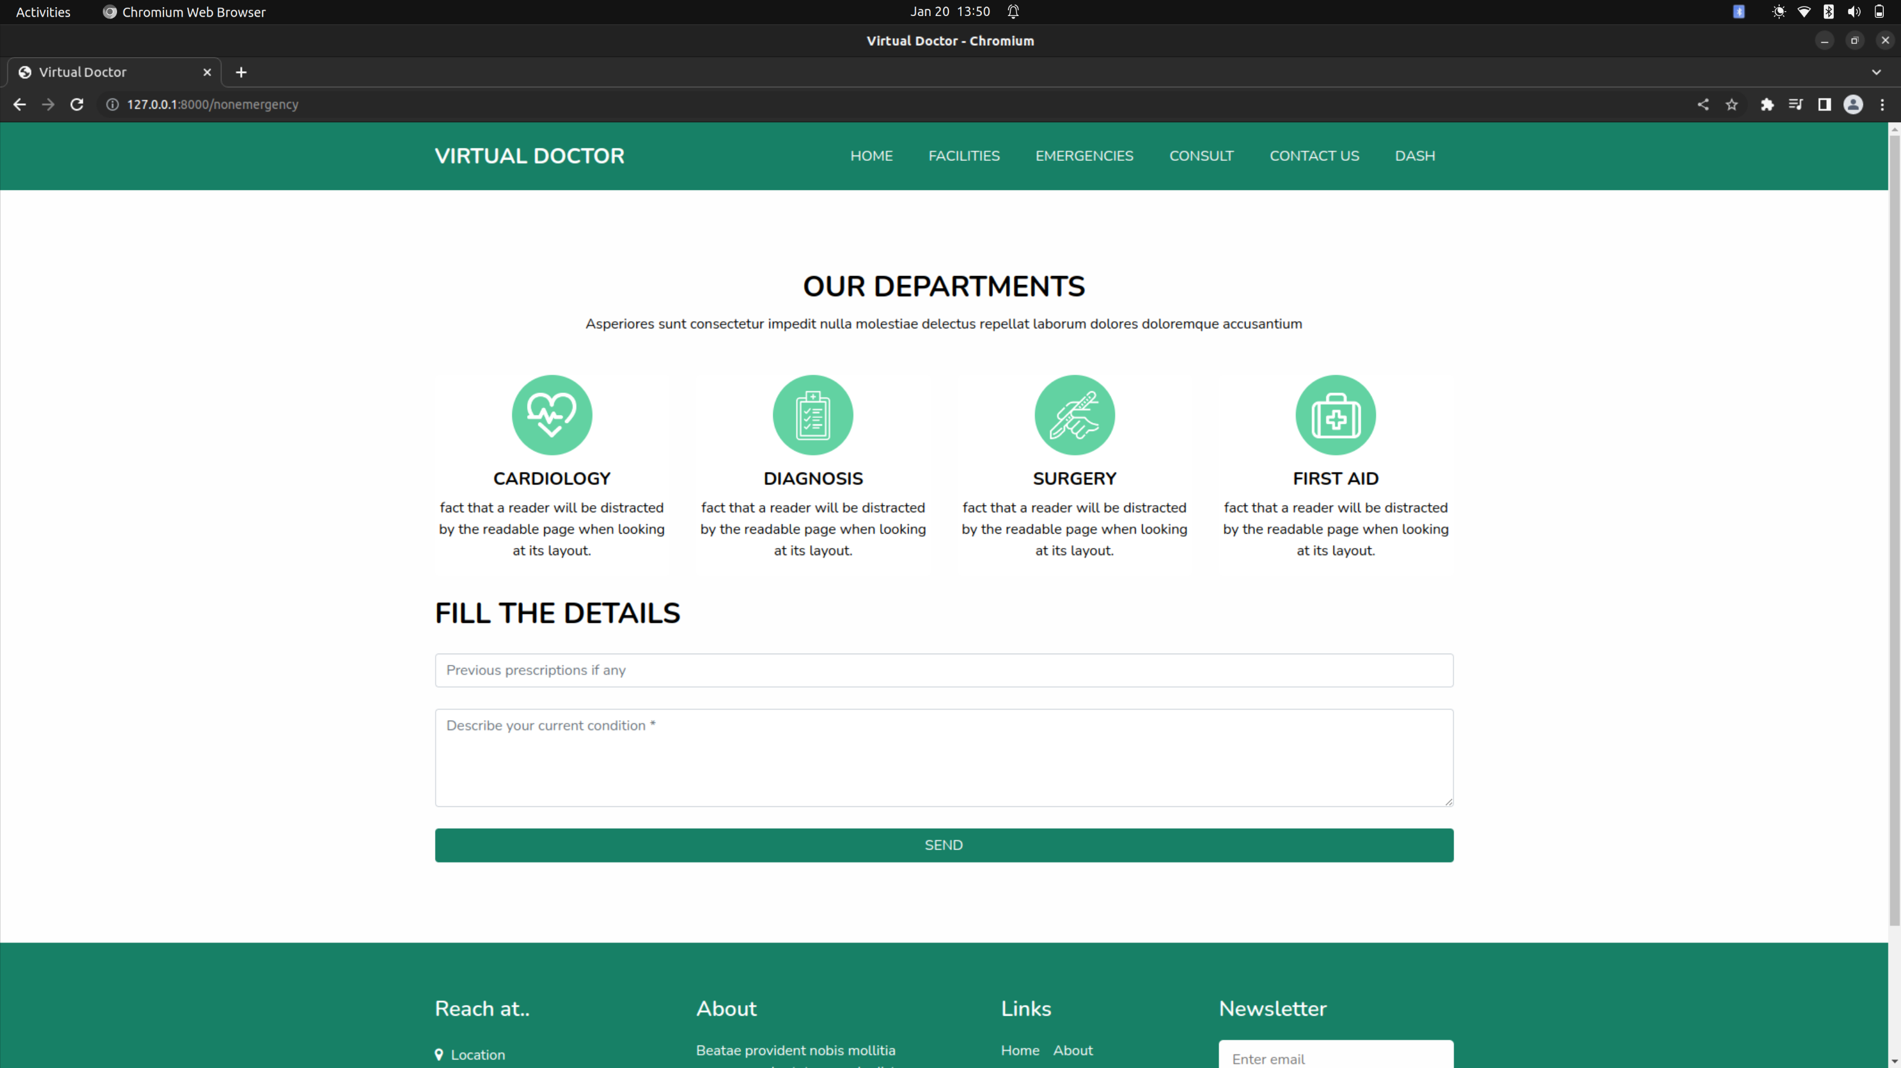**Figure 17: Consult Interface**

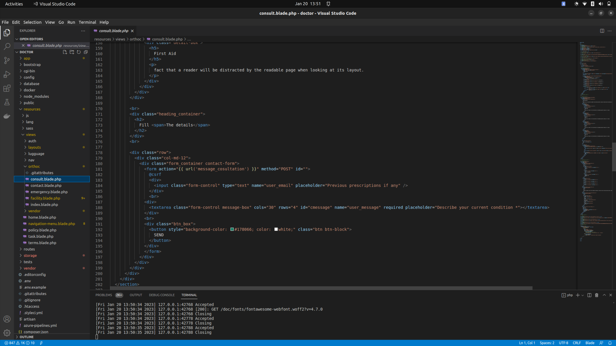**Figure 18: Consult Code**

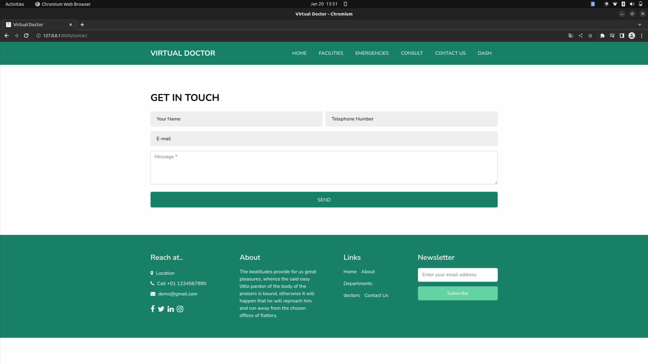**Figure 19: Contact Interface**

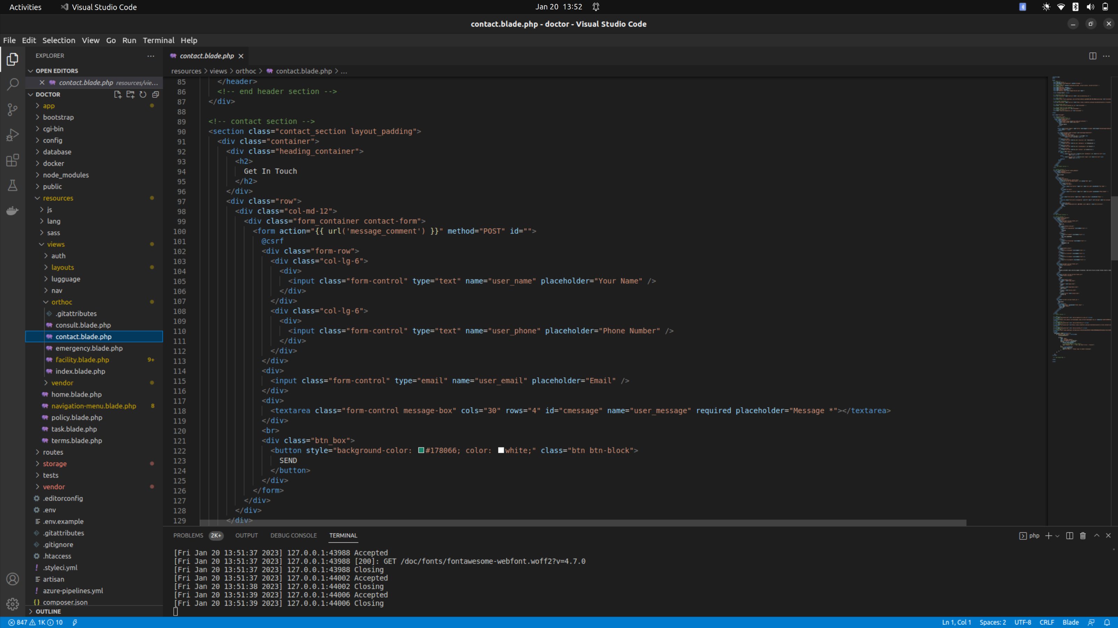**Figure 20: Contact Code**

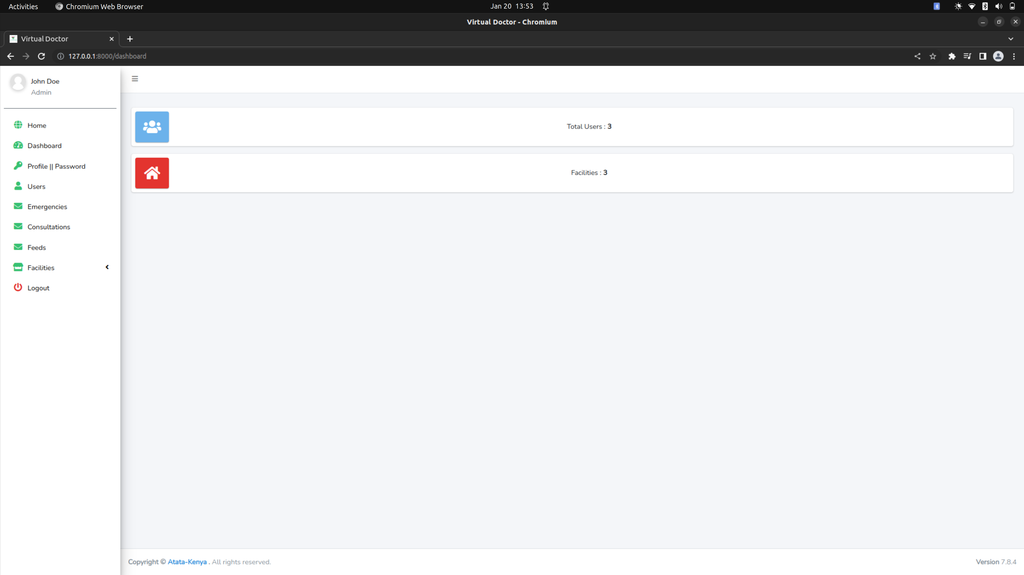**Figure 21: Dashboard Interface**

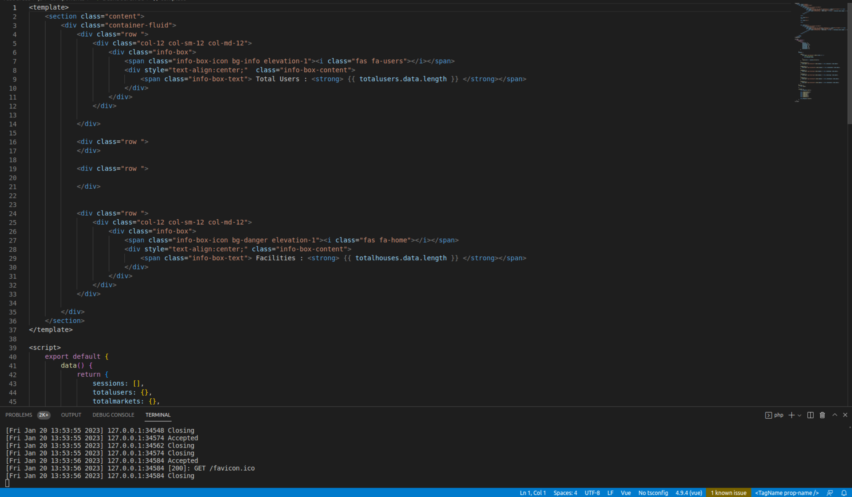**Figure 22: Dashboard Code**

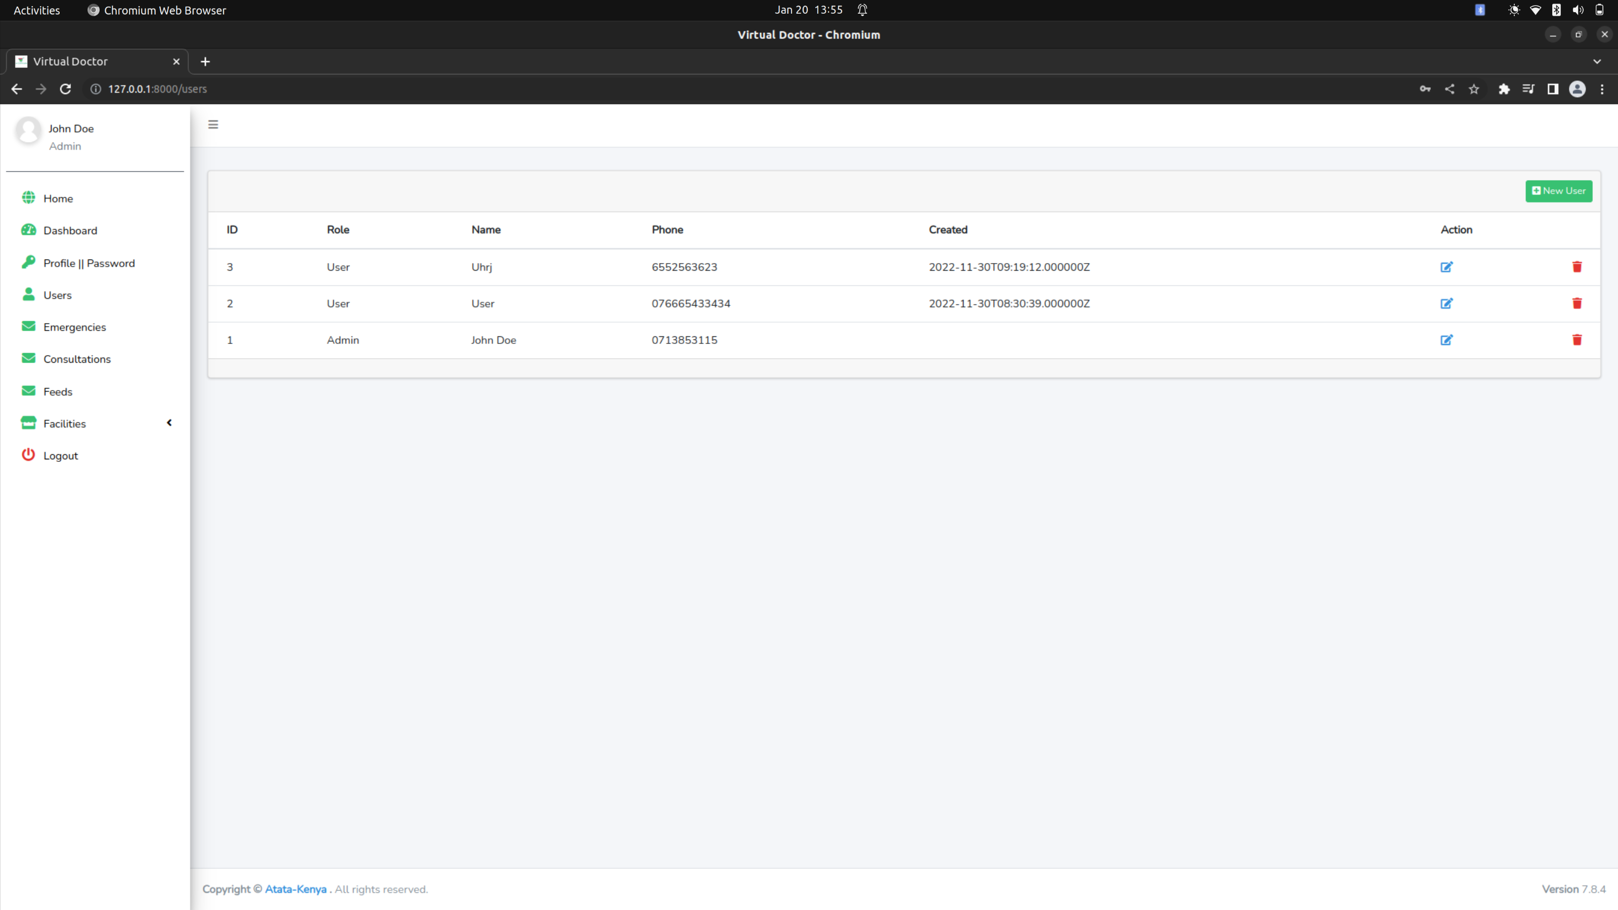**Figure 23: users Interface**

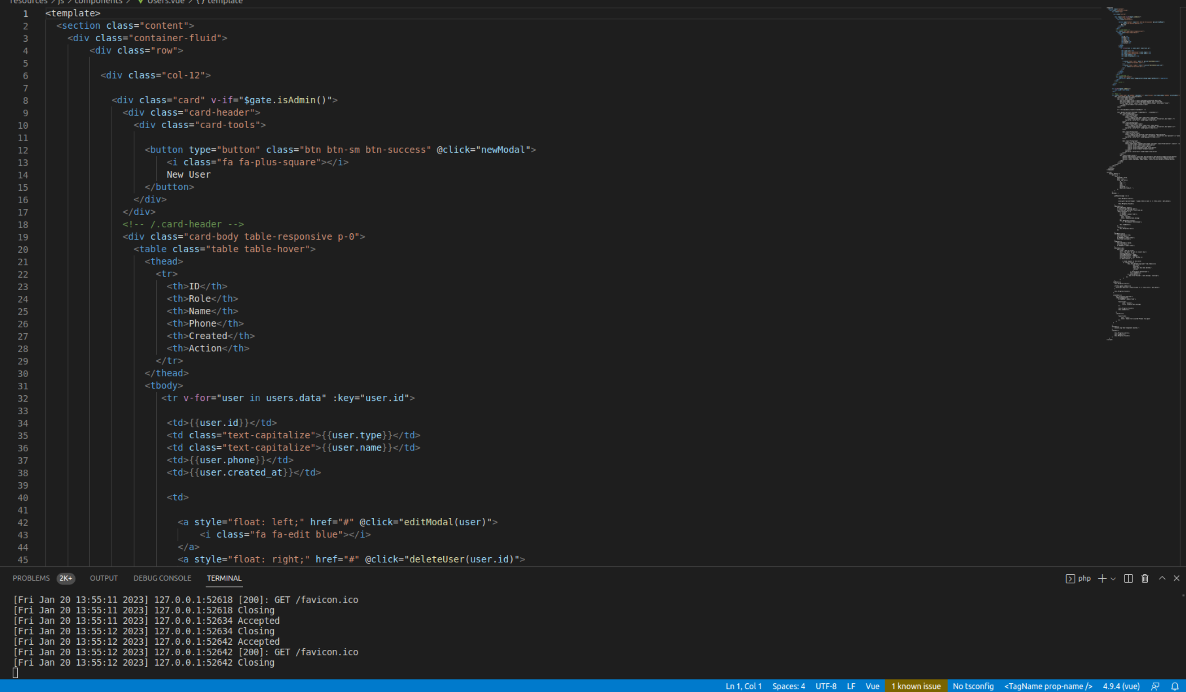**Figure 24: users code**

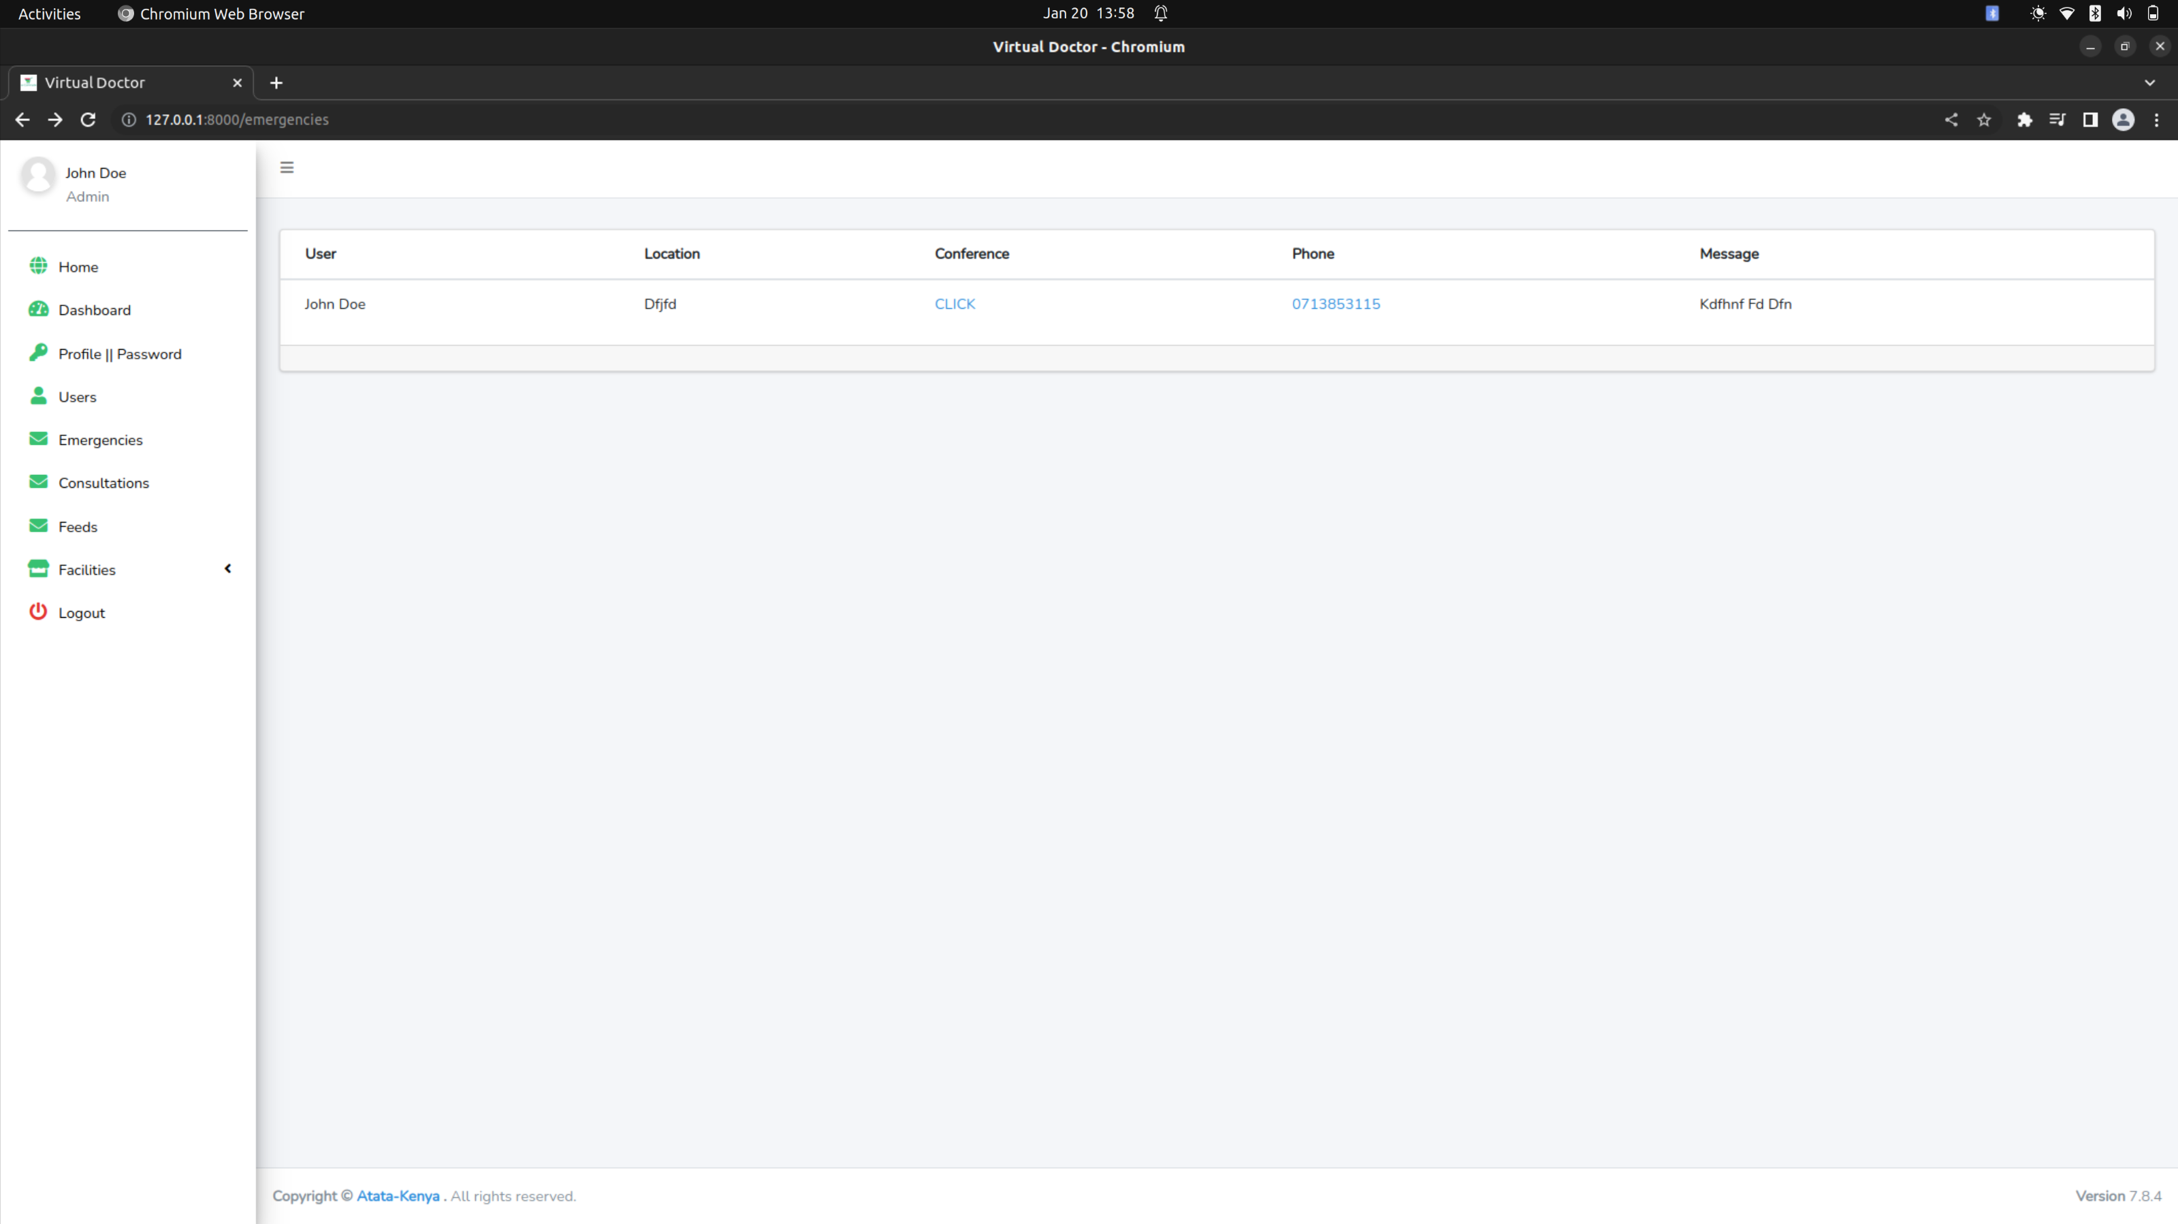**Figure 25: Emergence Interface**

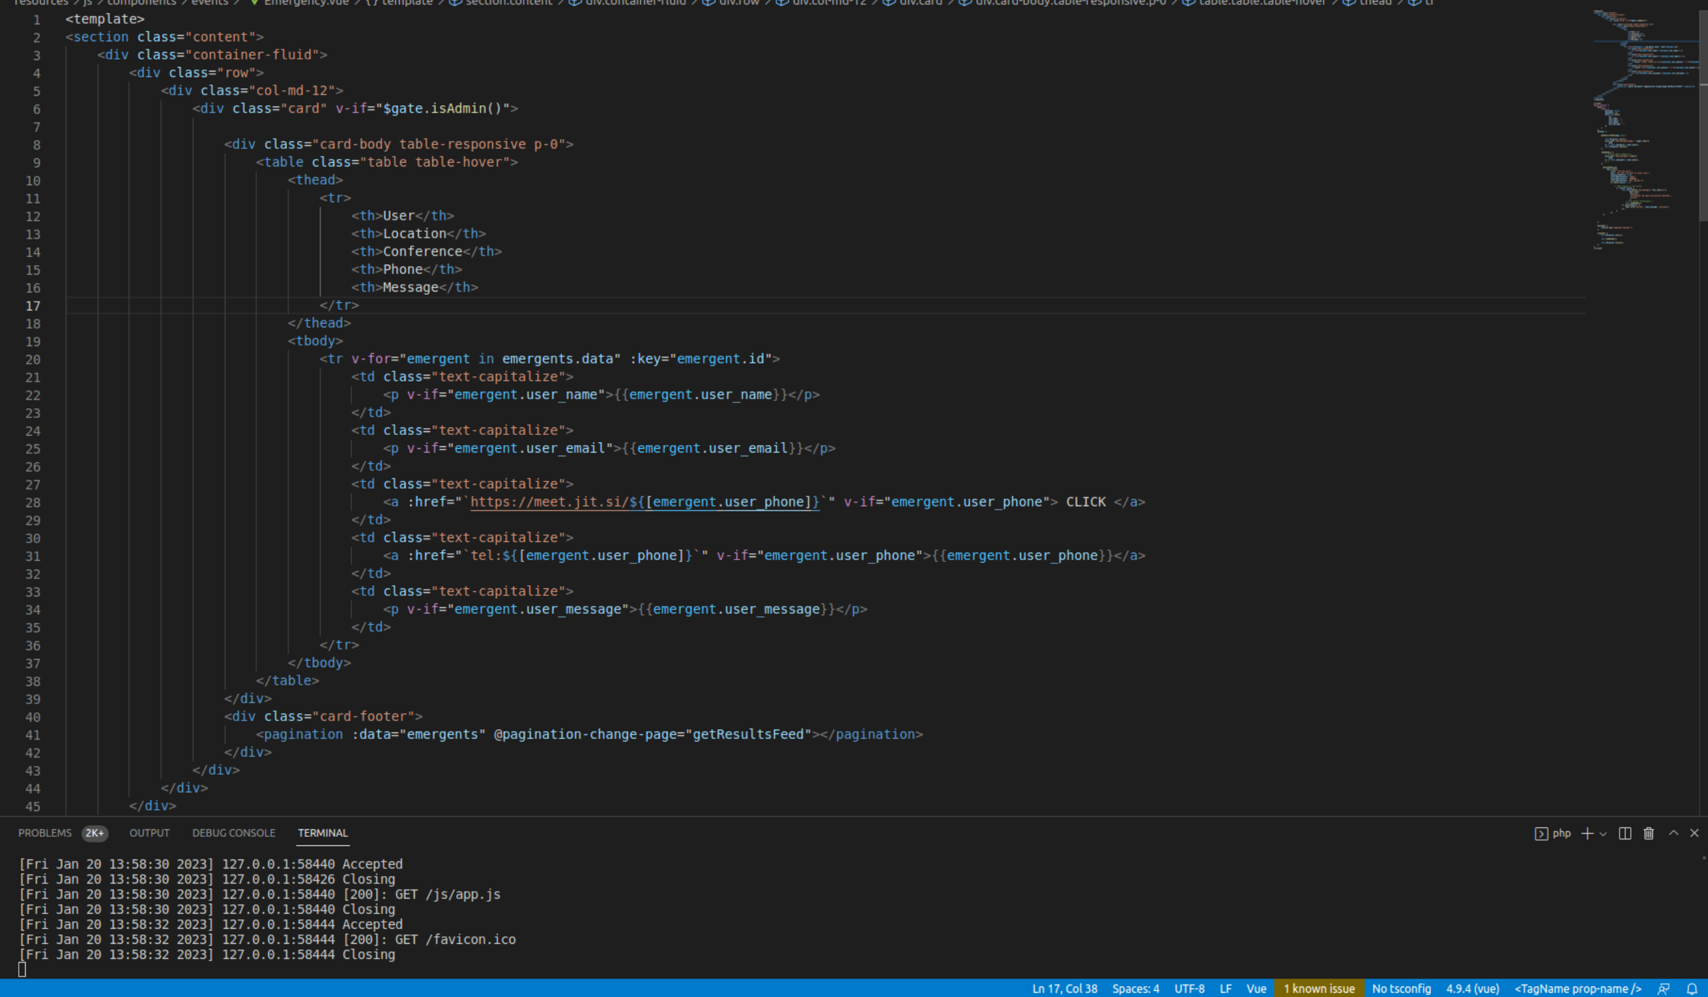**Figure 26: Emergence Code**

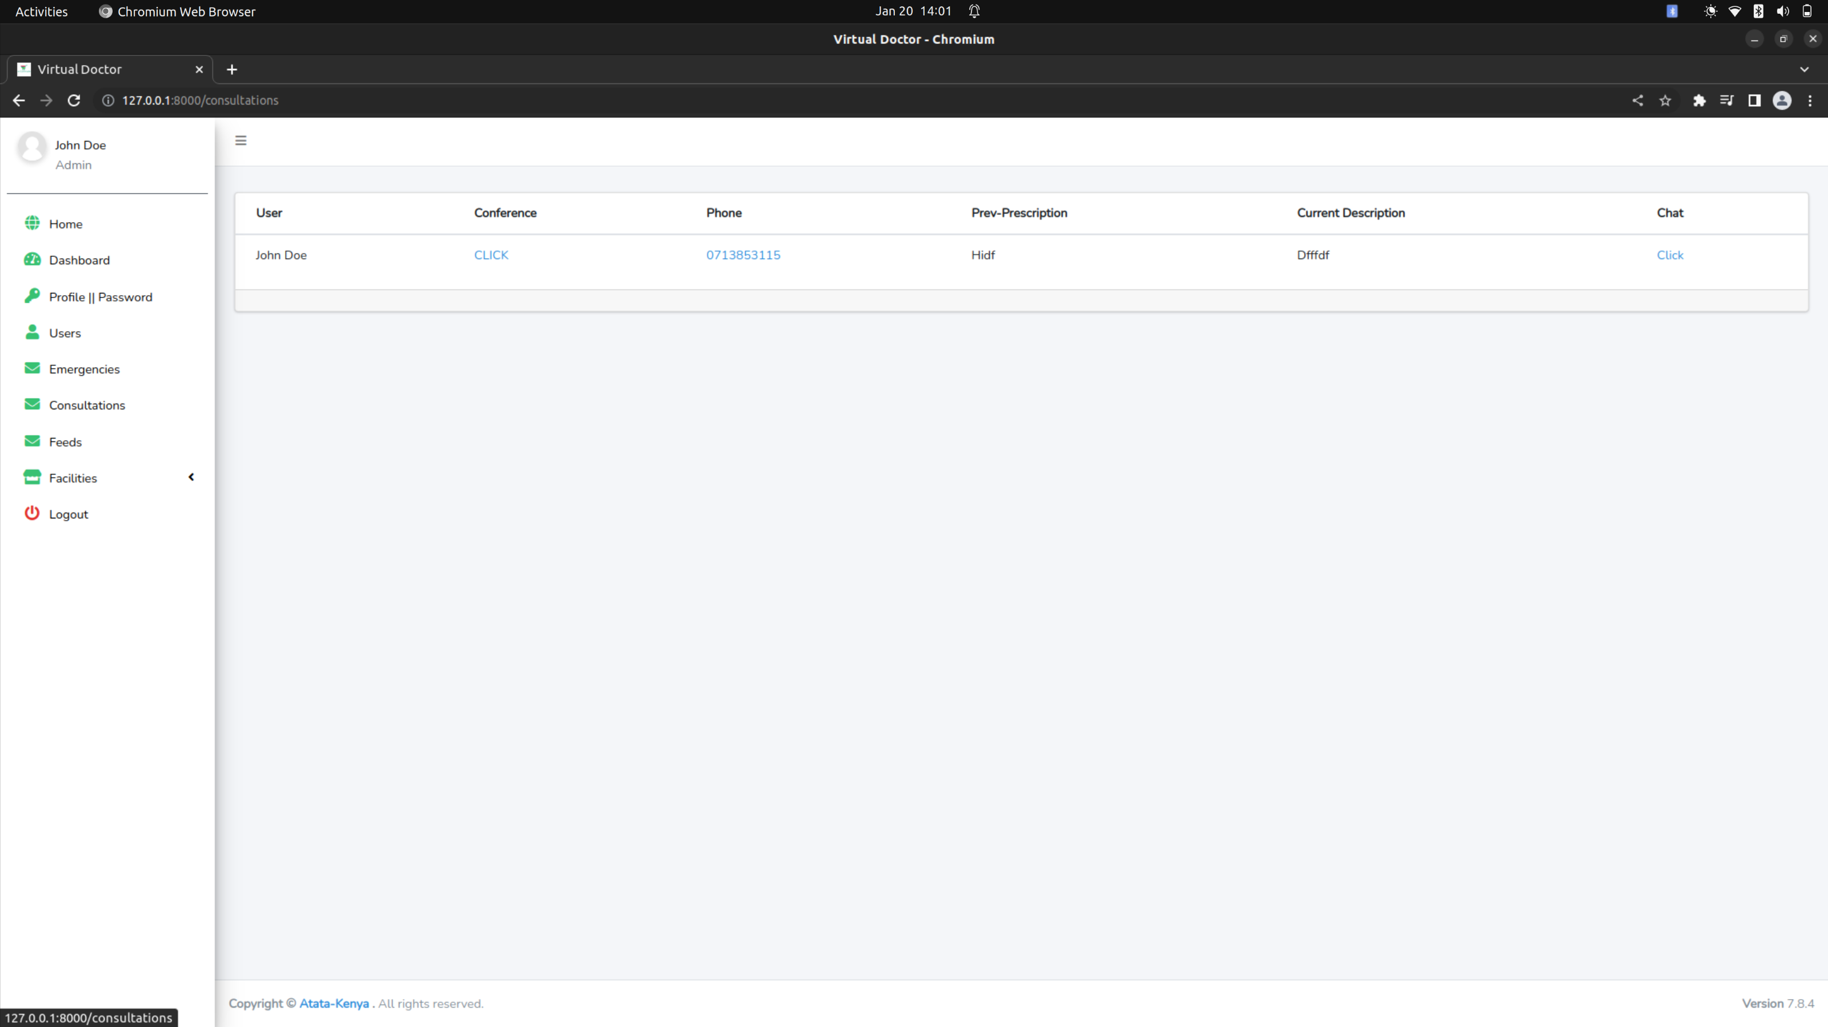

**Figure 27: Consult Interface**

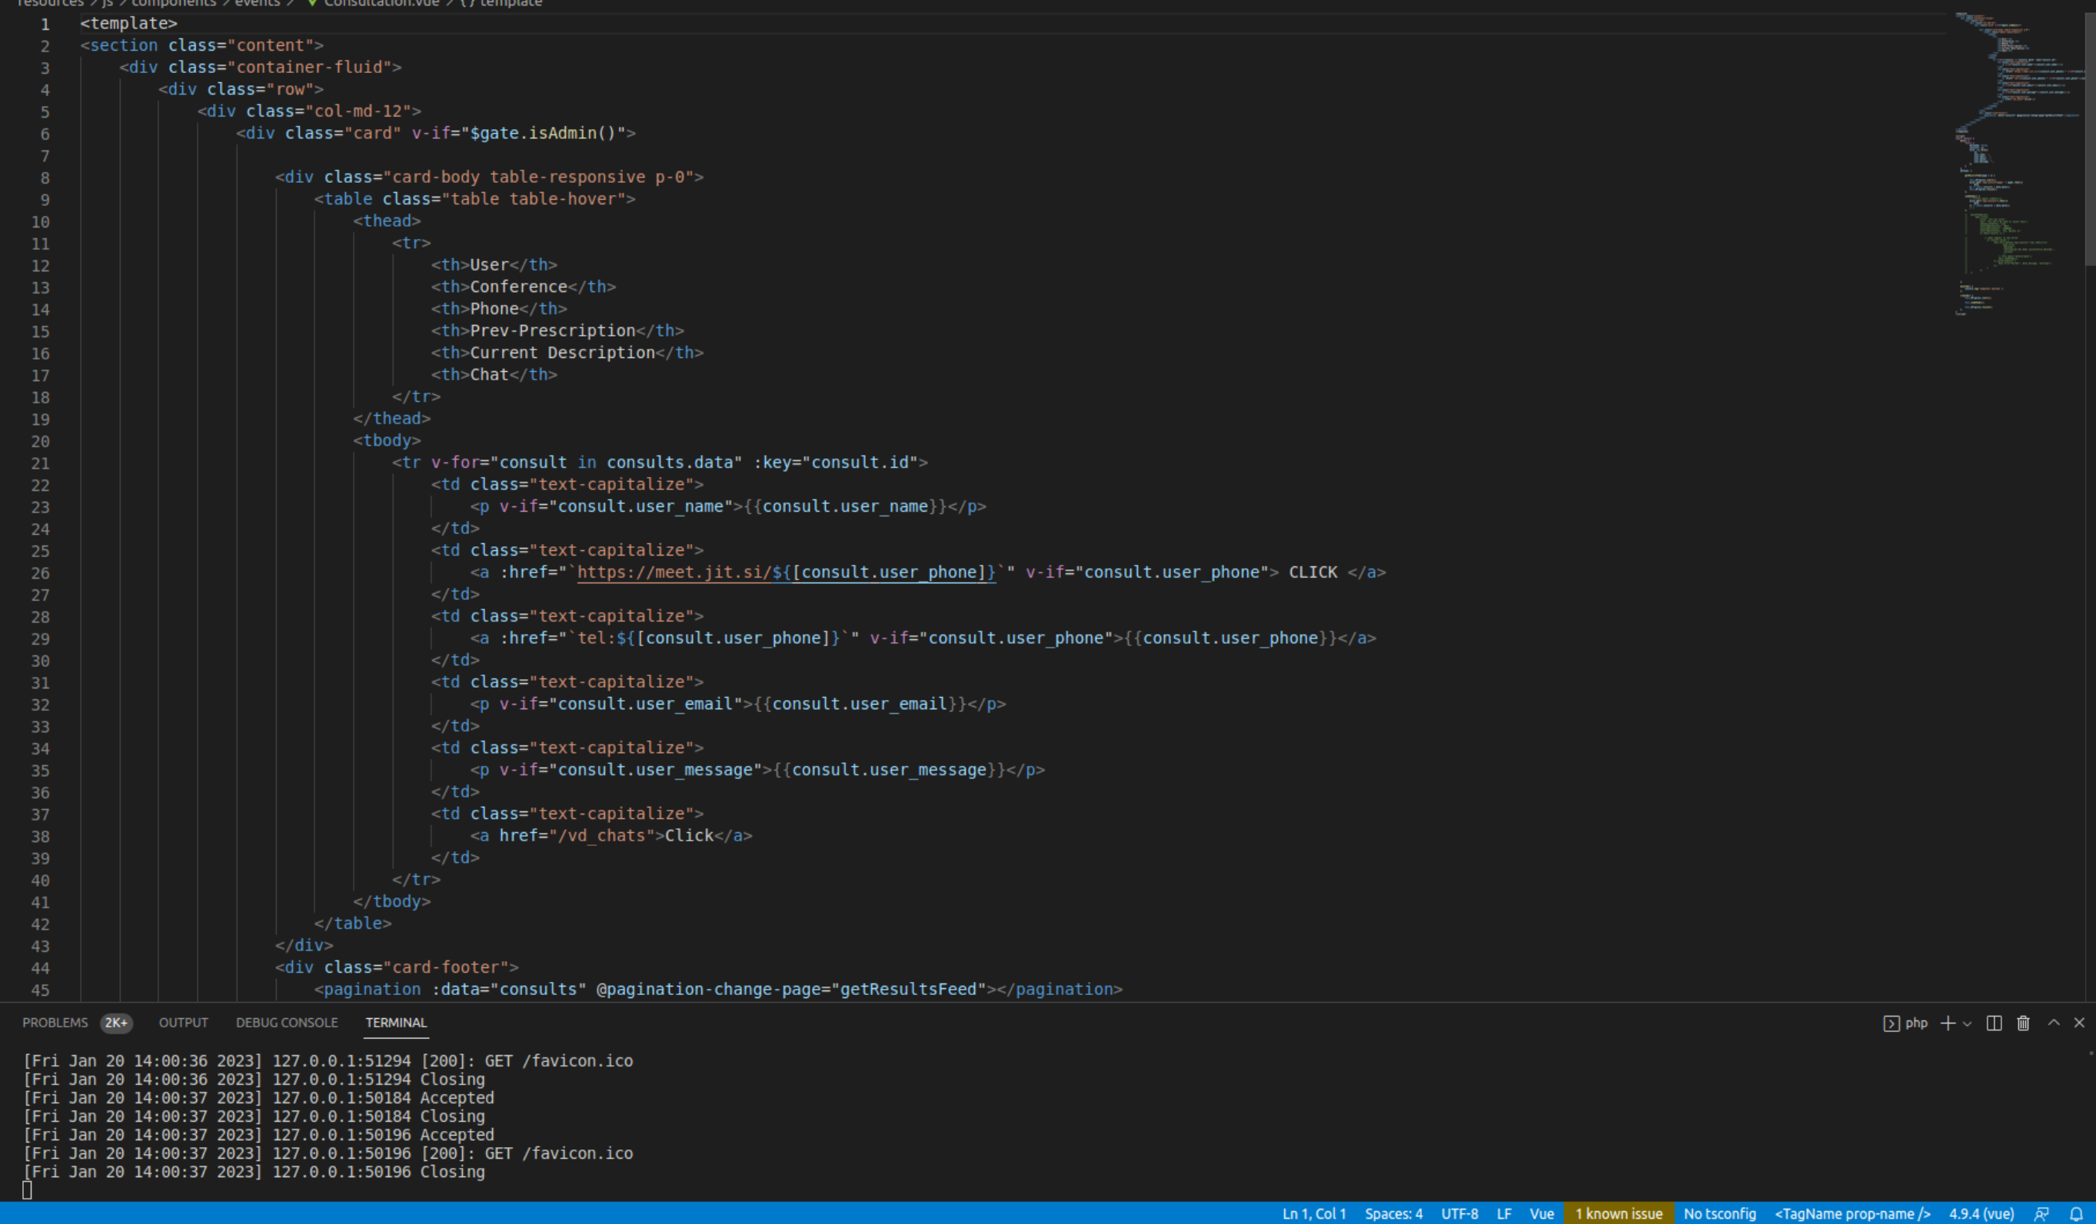**Figure 28: Consult code**

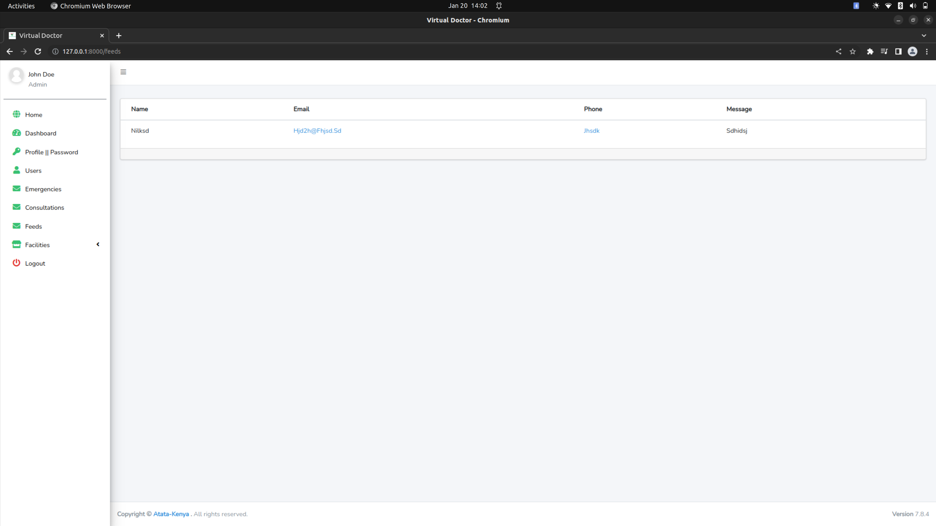**Figure 29: Feedback Interface**

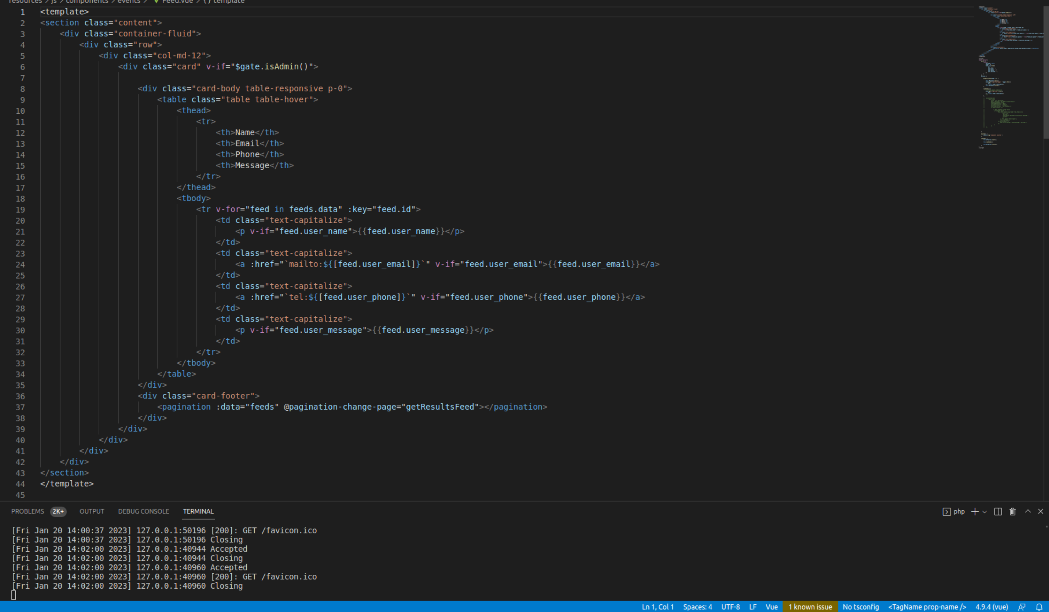**Figure 30: Feedback Code**

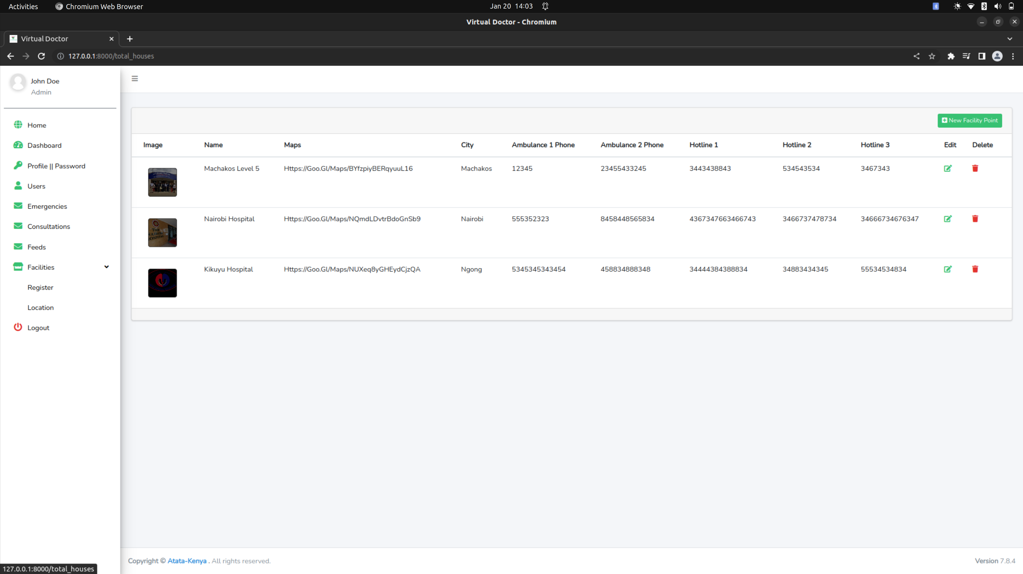

**Figure 31: Facility Interface**

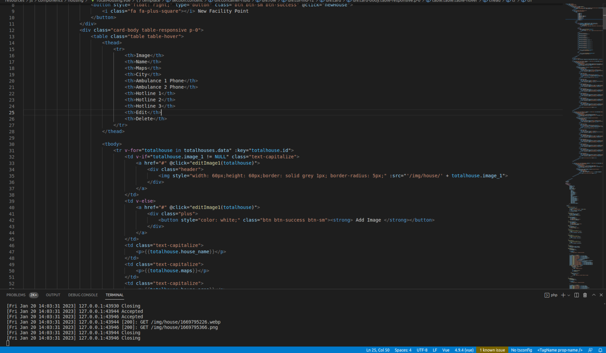**Figure 32: Facility Code**

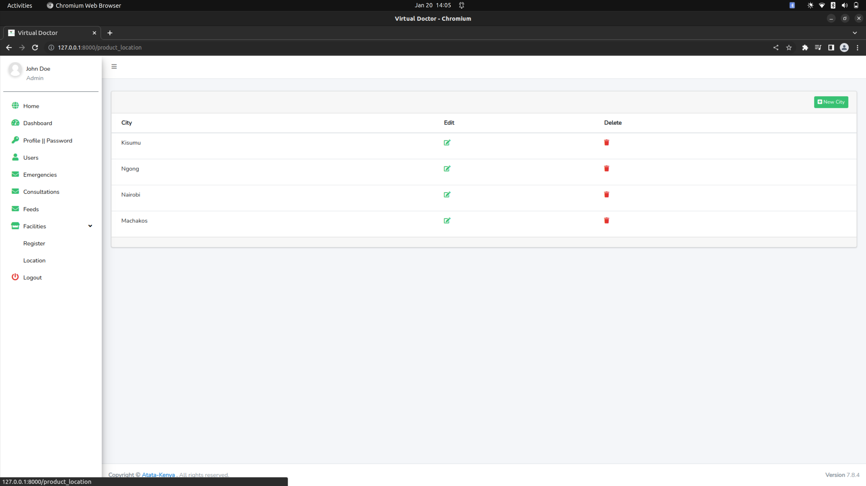**Figure 33: Location Interface**

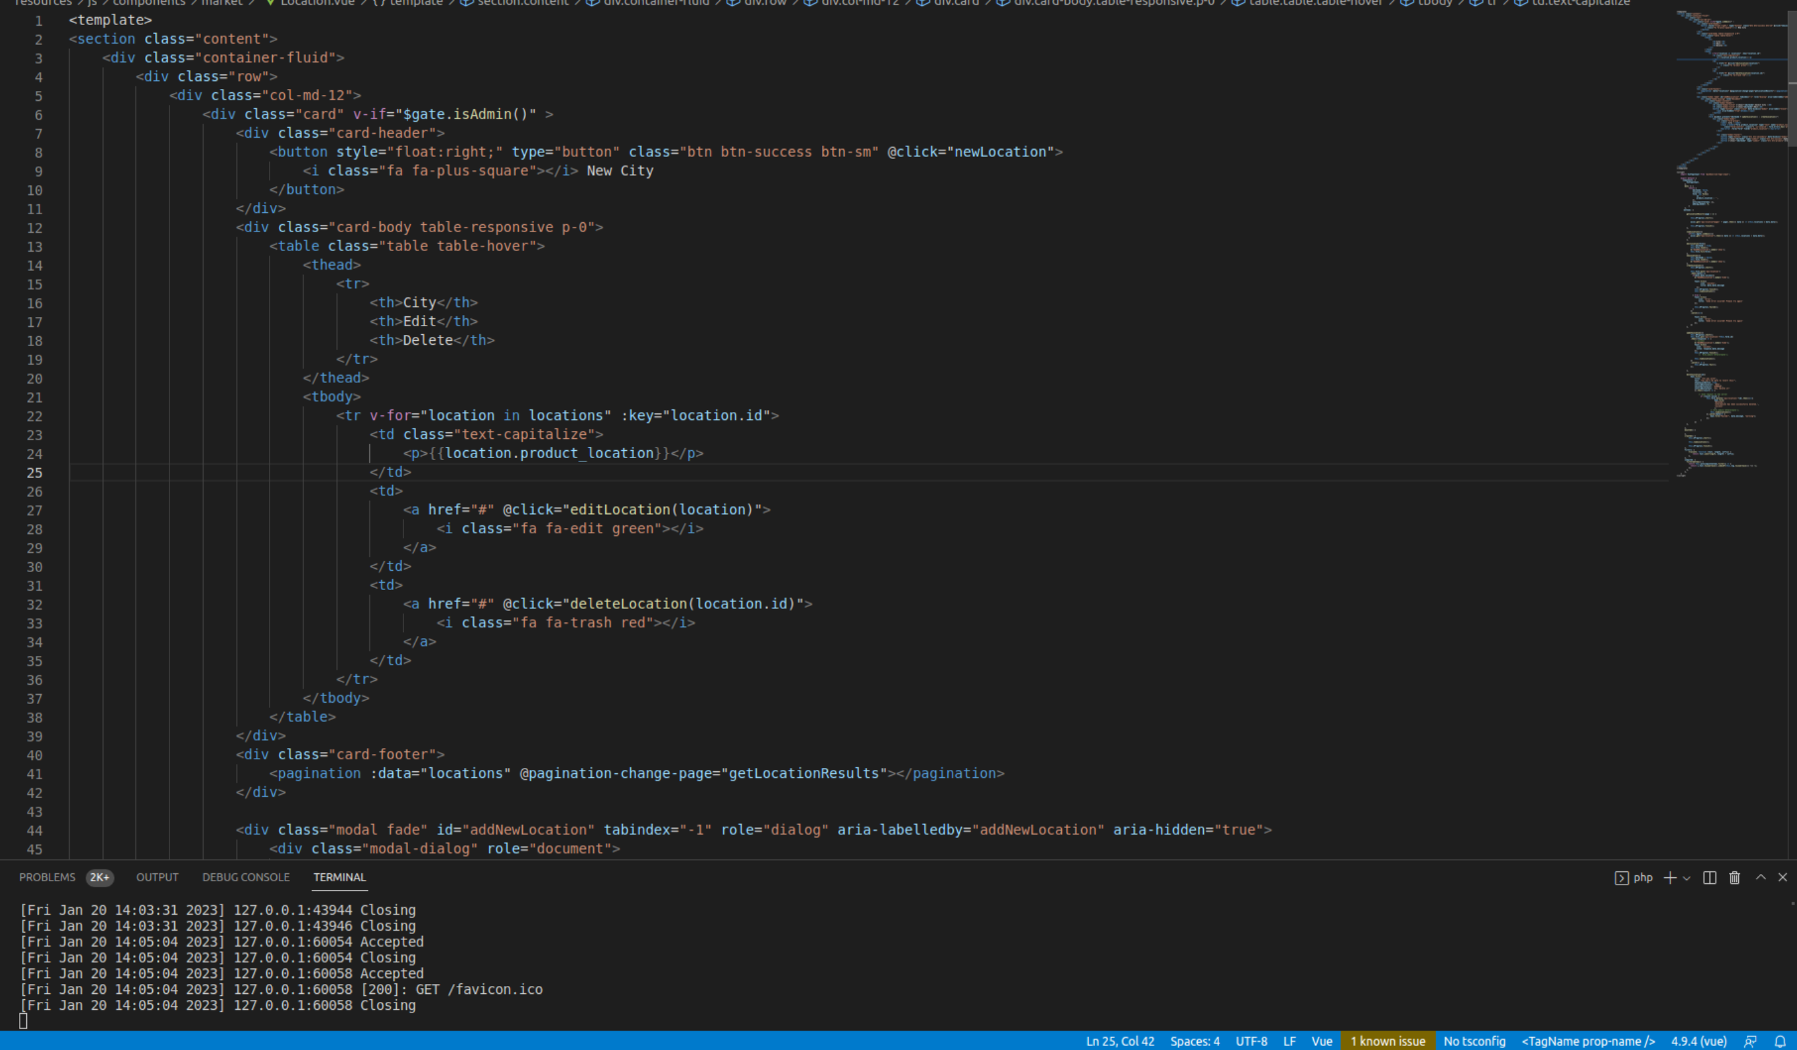**Figure 34: Location Code**

# **CHAPTER SIX**

# **CONCLUSIONS AND RECOMMENDATIONS**

## **6.0 Introduction**

On the onset of this study, the various aspects of problems of a virtual doctor system and the rising concern for computerization was discussed. The end result was there being a need for computerization of handling emergencies in the country. The different benefits of a good information management were carefully analyzed and the potentials in revenue collection were outlined.

## **6.1 Discussion**

The conceptual framework behind the virtual doctor system was analyzed using relevant related literature and different models that have been developed by certain scholars. An overview of the Machakos area, selected for the demonstration of the sample system.

## **6.2 Recommendation**

Considering the rapid advancement in the information technology world and the large number of documents that are being handled by organizations daily, combined with the need for accountability and proper document management, it is therefore highly recommended that organizations implement a secure online document management system. There are high economic advantages attached to this software on the part of the organization and users. Above all, it is user-friendly and documentation should be checked in case of future modification.

## **6.3 Future Work**

Additional modules should be included into the system to increase the system's functioning. These aspects of the system that need to be improved may have been overlooked during the construction of the existing system. These will improve the overall system's performance.

Areas of further research would include:

1. User tracking to enable fast and easy tracing of emergent patients and places

2. Use oof mobile applications for easy accessibility.

3. The use of machine learning to get the web application working efficiently.

## **6.4 Conclusion**

The research findings and analysis of data have brought to light several factors relating to research problem. The fact that there is minimal ways to handle emergencies as regard ease of information retrieval has come out very clearly. There is therefore a need for change to more efficient means of information system in order to tap the full potentials of the use of virtual doctor.

# **REFERENCES**

1. Arent Fox. Federal Telemedicine Legislation 104th Congress. Telemedicine and the Law. May, 1996.
2. Bailar JC. The Practice of Meta-analysis.Journal of Clinical Epidemiology. 1995;48(1):149–157. [[PubMed](https://www.ncbi.nlm.nih.gov/pubmed/7853040)]
3. Ball JR. Practice Guidelines and Their Role in Quality Assurance and Cost Effectiveness. Quality Assurance in Health Care. 1990;2(1):31–36. [[PubMed](https://www.ncbi.nlm.nih.gov/pubmed/2129481)]
4. ACR (American College of Radiology). Standards for Teleradiology. Reston, Va: ACR; 1994.
5. ACR/NEMA (American College of Radiology/National Electrical Manufacturers Association). Meeting of ACR/NEMA Working Group X; Washington, D.C. September 10, 1995;
6. Alemi F, Stephens R. "Computer Services for Patients: Description of Services and Summary of Findings.". Medical Care. 1996;(Supp) in press. [[PubMed](https://www.ncbi.nlm.nih.gov/pubmed/8843932)]
7. Alemi F, Higley P. Reaction to "Talking" Computers Assessing Health Risks. Medical Care. 1995;33(3):227–233. [[PubMed](https://www.ncbi.nlm.nih.gov/pubmed/7861825)]
8. Allen A. In the Beginning (Part II): Telemedicine and Teleradiology. Telemedicine Today. 1994;2(3):6–7.
9. Allen A. Prison Telemedicine in Colorado. Telemedicine Today. 1995A;3(4):26–27.
10. Allen A. UTMB-Galveston: In a League of Its Own. Telemedicine Today. 1995B;3(2):15–16.
11. Allen A. Teleradiology I: Introduction. Telemedicine Today. 1996;4(1):24
12. Allen A, Allen D. Telemental Health Services Today. Telemedicine Today. 1994A;2(1):12–24.
13. Allen A, Allen D. Teleradiology 1994. Telemedicine Today. 1994B;2(3):14–23.
14. Allen A, Perednia D. Telemedicine and the Health Care Executive. Telemedicine Today. 1996 Winter;(special issue):4–9. 22, 34. Reprinted from ComNets 2(9):59-64, 1996.

**APPENDICES**

## **Budget**

The following table below represents the budget that will be incurred during the development of the proposed project.

|  |  |  |  |  |  |
| --- | --- | --- | --- | --- | --- |
| **Item** | **Description** | **Units** | **Price per unit (Ksh.)** | | **Total**  **cost (Ksh.)** |
| Mysql Standard Database | Multi Core 64bit x86,8GB RAM, 1920×1200 display. | 1 | 237,200.00 | | 237200.00 |
| Computer | Intel CPU: Quad core 2GHZ or Higher,  AMD CPU: Quad core 3GHZ or Higher,  8 GB RAM ,  500 GB Standard Hard Drive (250 GB Solid State Hard Drive)  Monitor: 1080p Broadband with 10 Mbs download and 1.0 Mbs upload. | 1 | 65,000.00 | | 65,000.00 |
| Hosting provider | UnlimitedNVMe SSD Disk Space,  8GB RAM,  PHP 7.4, 8.0, 8.1, | 1 | 11,000.00 | | 11,000.00 |
| **Total** | | | | 313,200.00 | |

**Table 1: Budget**

## **Project Activities**

Project activities are the actions that will take place during the development of medical research management system. These activities include: Feasibility study, study investigation, System analysis, system design, coding, testing, implementation of the project and finally system documentation. The duration is the time that it will take for each activity to be completed.

|  |  |
| --- | --- |
| **Activity** | **Duration** |
| feasibility study | 2 weeks |
| Study | 3 weeks |
| System Analysis | 2 weeks |
| System Design | 2 weeks |
| Coding | 4 weeks |
| Testing | 2 weeks |
| Implementation | 2 weeks |
| Documentation | - |
| Total | 17 weeks |

**Table 2: Project Schedule**

## **Project Schedule**

The Gantt chart will be used to show the proposed project system development schedule.

|  |  |  |  |  |  |  |  |  |  |  |
| --- | --- | --- | --- | --- | --- | --- | --- | --- | --- | --- |
| Activities | 2 | 4 | 6 | 8 | 10 | 12 | 14 | 14 | 18 | 20 |
| Planning |  |  |  |  |  |  |  |  |  |  |
| System Analysis |  |  |  |  |  |  |  |  |  |  |
| System Design |  |  |  |  |  |  |  |  |  |  |
| Development |  |  |  |  |  |  |  |  |  |  |
| Testing |  |  |  |  |  |  |  |  |  |  |
| Deployment |  |  |  |  |  |  |  |  |  |  |
| Documentation |  |  |  |  |  |  |  |  |  |  |

**Table 3: Project Schedule**